

Kittitas County Plan for

Developmental Disabilities
“We value every individual as a contributing member of our community.”
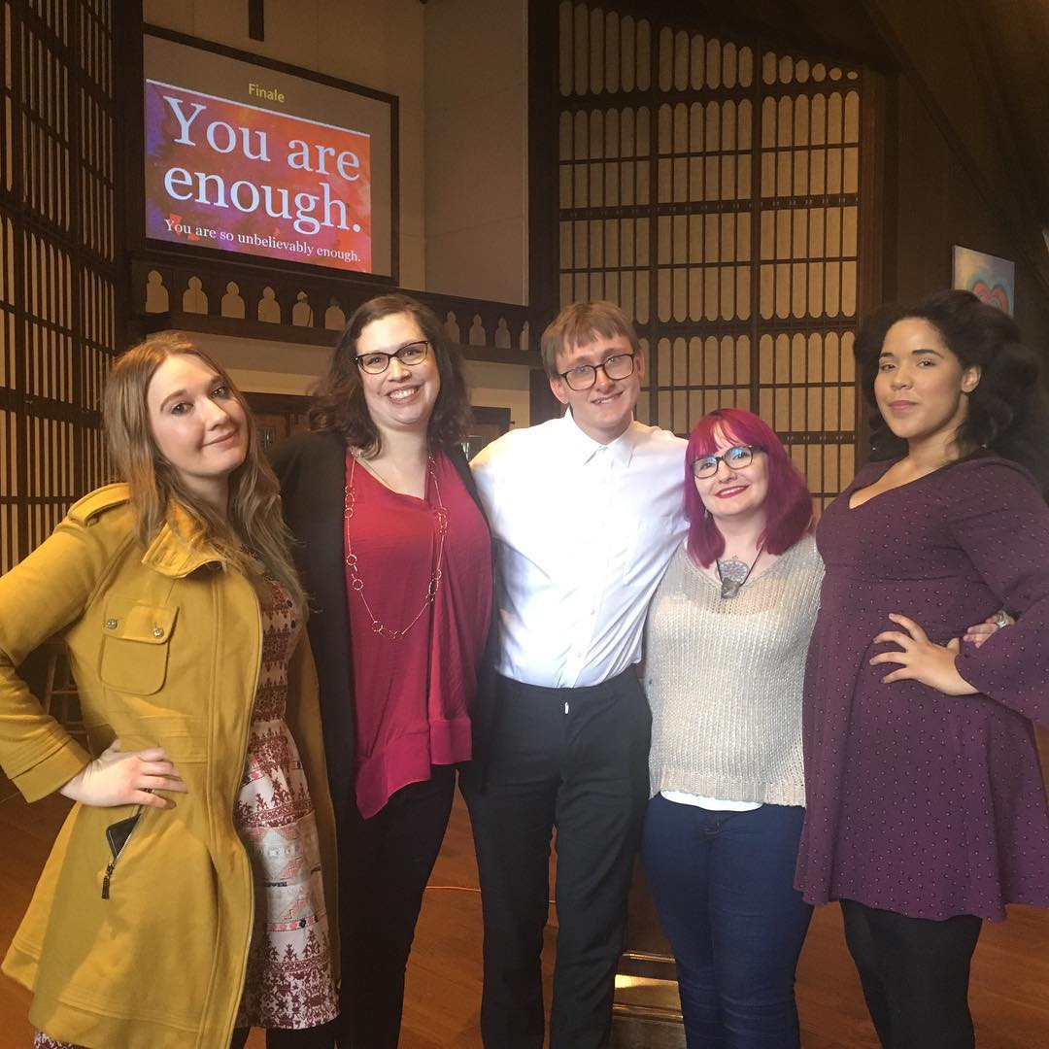

2024-2026

TABLE OF CONTENTS
TABLE OF CONTENTS 1
ACKNOWLEDGEMENTS 2
BACKGROUND 3
DEVELOPMENTAL DISABILITIES ADVISORY COMMITTEE 4
KITTITAS COUNTY PROFILE 8
PEOPLE WITH DISABILITIES 9
KITTITAS COUNTY DEVELOPMENTAL DISABILITIES PROGRAM 13
ASSETS, GAPS, OPPORTUNTIES, CHALLENGES 18
COMMUNITY SURVEY—summary of results 19
PRIORITIES 22
IMPLEMENTATION: GOALS, STRATEGIES, OBJECTIVES, ACTIVITIES 24
REFERENCES 28
APPENDIX A: ELIGIBILITY FOR DDA SERVICES 29
APPENDIX B: KITTITAS COUNTY SERVICES 32
APPENDIX C: COMMUNITY SURVEY RESULTS 35

Pictured on cover page (left to right): StreetKat (performer), Devin Beach, Harry Engel, K.B. Shinn, and Jacqueline Robinson.

ACKNOWLEDGEMENTS
The 2024-2026 Kittitas County Plan for Developmental Disabilities was developed by members of the Kittitas County Developmental Disabilities Advisory Committee (DDAC), in partnership with Kasey Knutson, the Developmental Disabilities Coordinator at the Kittitas County Public Health Department, and Robin Read, Community Consultant.
DDAC Members 2024

Toby Allphin
David McBride
Barbara Gregory
Justin Grindrod
Sarah Beauchamp
Amy Mohler
Hope Isitt
Brett Wachsmith
Rich Elliott

Jason Self

APPROVAL
The DDAC approved the final plan and recommended adoption of the plan to the Kittitas County Board of Commissioners on January 14, 2025.

ADOPTION
The Kittitas County Board of Commissioners adopted the plan on , 2025.


Laura Osiadacz, Chair

Cory Wright, Vice-Chairman

Brett Wachsmith, Commissioner

BACKGROUND
Per Washington Administrative Code 388-850-020, each county shall submit a written plan for developmental disabilities services to the Washington State Department of Social and Health Services, Developmental Disabilities Administration (DDA), every two years in alignment with the state’s fiscal biennium.
According to county guidelines from DDA, the county plan for developmental disabilities is intended to be developed by the county developmental disabilities advisory board and it aims to:
Developmental Disabilities Definition
Developmental Disabilities are a diverse group of chronic conditions due to mental/neurological or physical impairments or a combination of both. In general, developmental disabilities cause individuals difficulties in certain areas of life, such as language, mobility, learning, self-help, or independent living.
- Encourage and support the ability of communities to include people with developmental disabilities.
- Influence the direction of local developmental disabilities services.
- Help determine the direction of contracted services with input from persons with disabilities, families, and the community.
Furthermore, the guidelines state that plans should set program priorities, objectives, and tasks that inform and facilitate the allocation of resources in alignment with the program mission and values.
In Kittitas County, the Plan for Developmental Disabilities reflects the priorities of the Developmental Disabilities Advisory Committee and is used to guide the distribution of both state and local funding sources.



DEVELOPMENTAL DISABILITIES ADVISORY COMMITTEE
The Washington State Developmental Disabilities Administration requires developmental disability boards to exist as part of the county contracts that provide funding for employment and other support services for people with developmental disabilities. Kittitas County’s Developmental Disabilities Advisory Committee (DDAC) is responsible for developing the biennial plan and making recommendations to the county about developmental disabilities services and funding. It consists of nine community members who serve three-year terms (except for the County Commissioner Chair who is ad-hoc) who are committed to supporting opportunities for each Kittitas County citizen with developmental disabilities to realize his/her personal goals as full participants in the community. Committee members are people with developmental disabilities, or parents of; policymakers; and invested community members who aim to bring the voices of people with developmental disabilities (DD) to the community.
Revised Code of Washington (RCW)
The RCW provides authority to county governing authorities to establish a “developmental disability board to plan services for persons with developmental disabilities, to provide directly or indirectly a continuum of care and services to persons with developmental disabilities within the county or counties served by the community board. … Members appointed to the board shall include but not be limited to representatives of public, private, or voluntary agencies, representatives of local governmental units, and citizens knowledgeable about developmental disabilities or interested in services to persons with developmental disabilities in the community.”

Brett Wachsmith, Chair
“I serve on DDAC as a liaison to the Board of Commissioners. I’m proud of what has been accomplished and I am eager to see this committee tackle the upcoming goals.”
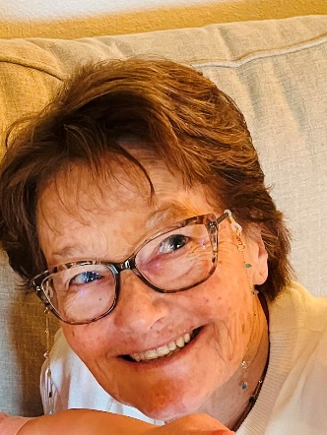
Barbara Gregory
“I have a loved one who is an enthusiastic member of an ever growing population of people in Kittitas County who live with developmental challenges. My goal as part of DDAC is to advocate for funding and services for 1) improvements in sidewalks & roads to provide safe mobility and 2) adaptive programs to support all of our citizens, including all with disabilities. It is an honor to assist in any way I can.”
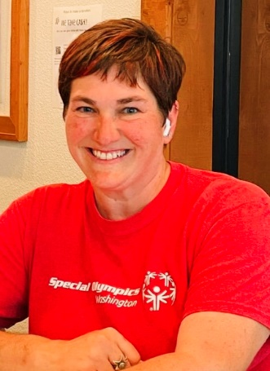
Amy Mohler
“I am really blessed to be connected to so many in our community with developmental disabilities & their families both through my work & as our local Special Olympics Coordinator. I am happy to be on this board to advocate for making our town a place that empowers people with disabilities to live their best lives & engages supports that allow that to happen.”

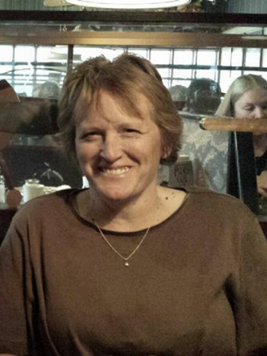

Toby Allphin
“I am on the committee as a parent of a son with special needs. We feel very good that we live in a country that cares.”


Justin Grindrod
“I am a self advocate who wants to bring my lived experience to the board & give back to my community. I like to help others & be a voice to make things better for those of us receiving services.”

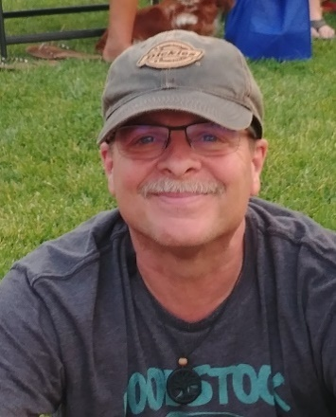
David McBride
“I have a loved one with Cerebral Palsy. As such, I am very aware of challenges faced by the disabled and their families. I truly hope to help make a difference in this community by serving on this committee.”


Hope Isitt
“I am excited to be serving as a volunteer community member on the Developmental Disabilities Advisory Committee for Kittitas County. As a family member of a young adult with autism, a veteran professional educator and a Special Olympics Coach, it is my hope that I can share my experiences with a variety of public programs in a way that will help other members of the community to better access services in our area. We have an opportunity as an Advisory Council to share our stories and knowledge in order to help guide policies in our county and in the state to improve the daily lives of those around us living with developmental disabilities. Thank you for this opportunity to serve our community.”

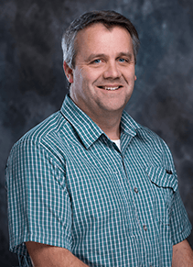
Rich Elliott
“I am active in the community focusing on improving behavioral and mental health resources and access to healthcare. It is an honor to serve. I am deeply committed to this community.”
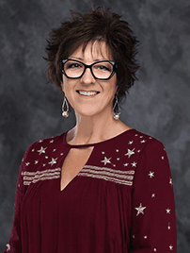
Sarah Beauchamp
“I work in the community to promote and encourage inclusivity and diversity.”
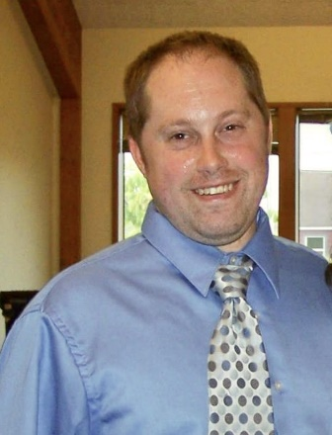
Jason Self
“I participate in the Kittitas County Developmental Disabilities Advisory Committee, because advocacy is important. I have been an advocate for many years including participation on the state developmental disabilities advisory council for the past 6 years, the Arc of Washington State for the past 15 years, and People First of Washington.”

Vision, Mission, & Guiding Principles
Vision
All people with developmental disabilities will have the opportunity to reach their full potential, achieve their dreams, live fulfilled lives, and be contributing members of our community.
Mission
To foster an inclusive environment that supports citizens with developmental disabilities and their families to participate in and contribute to all aspects of the community.
Guiding Principles
Inclusion is the ability to be present and included in our neighborhoods, schools, community groups, religious spaces and recreational activities. Inclusion offers us opportunities to meet others, participate in community life, and feel welcome.

Power and Choice mean recognizing what we want and how to achieve it. Power is having the ability to direct or influence our own lives. Choice is the opportunity to make decisions that are right for us and includes the opportunity to succeed or fail.

Health and Safety mean the ability to live and work in a safe place, to have access to quality health care, and to learn what we need to do to take care of our health and safety needs.

Competence is learning to do things that make our lives better and being supported to do things for ourselves. It includes communicating effectively with those who provide us with supports and being able to direct those supports.

Contribution is feeling good about ourselves, being valued and well regarded by others, and being recognized for what we contribute to our community.

Relationships offer a sense of belonging, continuity, intimacy and give meaning to life. Connection to others provides support and opens doors to new opportunities and experiences.
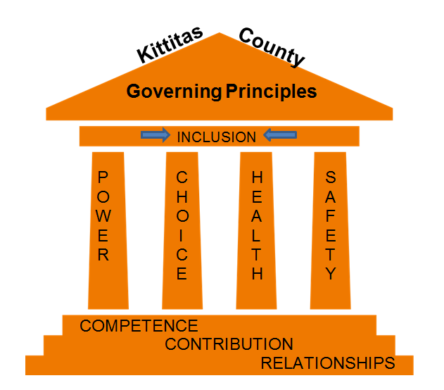

KITTITAS COUNTY PROFILE
Kittitas County is in the center of Washington State on the east side of the Cascade Mountains. The county is surrounded by several mountain passes (Blewett, Snoqualmie, Manastash) and is nearly 2 hours away from the largest urban area in the state (Seattle.) Other larger cities nearby include Yakima (45 minutes away) and Wenatchee (1.5 hours away.) In other words, there are multiple geographic barriers to accessing a comprehensive range of services.
With a population of about 47,300 people and about 45% living in unincorporated areas, there is one primary care physician per 1,700 residents (compared to one per 1,180 Washington State), one mental health provider per 500 residents (one per 220 WA), and one dentist per 1,820 residents (one per 1,170 WA). These ratios would be even worse taking into account only those providers who accept Medicaid as insurance. Access to medical, dental, and mental health care is made more difficult by the shortage of providers in addition to the fact that 8% of adults in Kittitas County lack health insurance.
Compared to Washington state, residents of Kittitas County experience higher rates of poor physical and mental health days, frequent physical and mental distress, adult smoking, excessive drinking, child mortality, food insecurity, suicide, and sexually transmitted infections. Residents have less access to healthy food sources and exercise opportunities. However, Kittitas County has better life expectancy and lower HIV prevalence, drug overdose deaths, alcohol-impaired driving deaths, teen births, deaths due to injury, and preventable hospital stays.
Unemployment rates are 6.3% (compared to 5.2% in WA), 13% of children live in poverty (compared to 12% in WA), income inequality is higher than the state, and the median household income is significantly lower than Washington State as a whole ($62,700 compared to $84,200 in WA). Severe housing problems are more prevalent as well: only 60% own homes, and 19% of households spend 50% or more of their income on housing. The childcare cost burden is high and voter turnout is low. However, violent crime is significantly lower than Washington State, and high school graduation rates are higher.
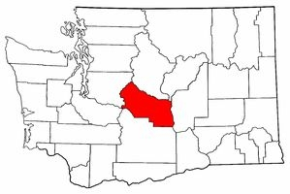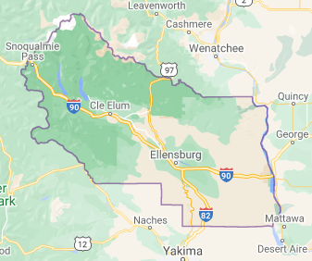

PEOPLE WITH DISABILITIES
According to the U.S. Census Bureau, 13% of the population, both in Kittitas County (approximately 5,700 people), and in Washington State is disabled. In Washington State, 74% of DDA clients live with their parents or relatives. Nine percent live in their own homes, 7% are in supported living environments, and about 3.6% live in adult family homes.
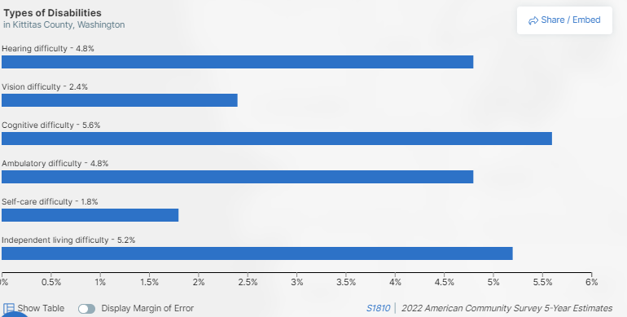
According to the 2023 Caseload and Cost Report from the Washington State Developmental Disabilities Administration, 78.6% of those determined to be eligible for services are diagnosed with a developmental delay, followed by 6.4% with autism, and 6.0% with an intellectual disability. (See table below.)

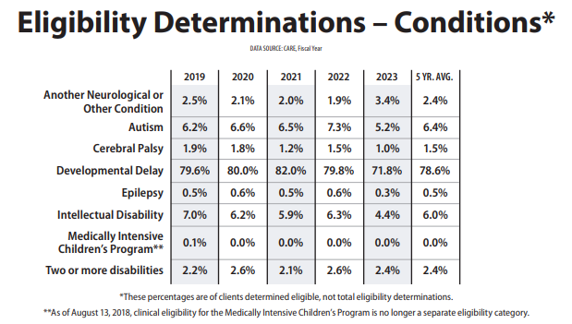

EMPLOYMENT & INCOME
In Kittitas County, 43% of people with disabilities are employed compared to 59% of people without disabilities. The unemployment rate of people with disabilities is 11% compared to 6% for people without disabilities. The rates of employment for people with disabilities is higher in Washington State compared to the United States as a whole. In Washington State, the employment rates of people with cognitive disabilities is significantly lower than people with hearing or vision disabilities (29.6% compared to 55.9% and 46.9% respectively.)
People with disabilities are more likely to work in the education service, manufacturing, retail trade, and office/administrative support industries and less likely to work in health care/social assistance and sales industries. Disability-related barriers to employment identified by customers of the Washington State Division of Vocational Rehabilitation (DVR) were work tolerance, communication, interpersonal skills, self-care, self-direction, work skills, and mobility. Other barriers included education/training, job skills, available jobs, job-seeking skills, and employer attitudes. Most customers work 20 hours a week or less and earn between $14.49-$18.99 per hour. The most helpful DVR services for employment are assessment, job search assistance, and counseling and guidance.
The median earnings of people with disabilities in Kittitas County was $29,320 compared to $38,639 for people without disabilities. This is a gap of $9,319 which is higher than the Washington State gap of $8,428 and the United States gap of $7,719. The poverty rate of people with disabilities in Washington State is 25.5% compared to 9.2% for people without disabilities.
Acuity
According to Washington Administrative Code 388-828-9200, acuity is defined by an algorithm that determines the level of employment support a DDA client can receive. The algorithm considers the following factors in determining acuity:
- Activities of daily living
- Behavioral support
- Interpersonal support
- Environmental support
- Level of monitoring
- Employment support
- Speed of completing tasks
- Quality of completing tasks
- Medical support
- Seizure support

Kittitas County Employment Support Clients, 2023
Acuity Level | Total clients | No hours/wages reported | Hours/wages reported | Minimum wage earned | Average hours worked per month
High Acuity Clients | 10 | 8 (80%) | 2 (20%) | 2  (100% of those working) | 2.8
Medium Acuity | 24 | 6 (25%) | 18 (75%) | 16  (89% of those working) | 18.4
Low Acuity | 2 | 0 (0%) | 2 (100%) | 2  (100% of those working) | 58
TOTAL | 36 | 14 (39%) | 22 (61%) | 20  (91% of those working)

EDUCATION
Nearly 15% of students enrolled in school districts in Washington State had a disability during the 2023-2024 school year. Fewer Washington State students with disabilities met grade level standards compared to students without disabilities (English Language Arts 18% vs. 56%, Math 15% vs. 43%, Science 17% vs. 47%). Sixty-seven percent of students with disabilities graduated in four years, compared to 86% of students without disabilities. About 19% of students with disabilities continue with their high school education after four years, and nearly 15% drop out (compared to 5% and over 9% for students without disabilities, respectively.) Students with disabilities also have lower rates of regular attendance (62% vs. 71%), significantly lower rates of kindergarten readiness (24% vs. 56%), and higher rates of discipline (6% vs. 2%).

SERVICES
The Washington State Department of Social and Health Services, Developmental Disabilities Administration (DDA) provides funding to counties for employment and other support services for people with developmental disabilities. Eligibility for services is determined by DDA and is based on Washington State residency, evidence of a qualifying developmental disability that began before age 18, and evidence of substantial limitations. DDA’s caseload has increased by an average of 3.66% per year over the past few years and their biennial budget has grown from $2.57 billion in 2015-2017 to $5.32 billion in 2023-2025. In 2023, Washington State had nearly 15,000 people with developmental disabilities who qualified for services but didn’t receive them due to lack of state funding (no-paid services caseload). That’s about 27% of all people on the DDA caseload.
Revised Code of Washington (RCW)
The Revised Code of Washington 71A.10.020(5) defines a developmental disability as: “a disability attributable to intellectual disability, cerebral palsy, epilepsy, autism, or another neurological or other condition of an individual found by the secretary to be closely related to an intellectual disability or to require treatment similar to that required for individuals with intellectual disabilities, which originates before the individual attains age eighteen, which has continued or can be expected to continue indefinitely, and which constitutes a substantial limitation to the individual.”
There are 53 children and 186 adults in Kittitas County currently enrolled in DDA. Sixty-three individuals are on the no-paid caseload, or 26%. In 2023, Kittitas County served 35 individuals in individual employment services and 42 individuals in community inclusion services.

KITTITAS COUNTY DEVELOPMENTAL DISABILITIES PROGRAM
The Washington State Department of Social and Health Services, Developmental Disabilities Administration (DDA) provides funding to counties for employment and other support services for people with developmental disabilities. Eligibility for services is determined by DDA and is based on Washington State residency, evidence of a qualifying developmental disability that began before age 18, and evidence of substantial limitations (see more detailed information about eligibility for DDA services in Appendix A). The funding varies based on availability, number of people receiving services, and the needs of each individual and is intended to help people keep a job or gain skills for obtaining employment. Kittitas County has received an average of around $1,000,000 per year for the past 5 years from DDA.

Additionally, per Revised Code of Washington 71.20.110, counties are required to annually budget and levy a property tax for developmental disabilities or mental health services. In Kittitas County, this tax is split equally between developmental disabilities and mental health services. Commonly referred to as “millage”, the county has discretion on how these funds are spent. The developmental disabilities program has received around $100,000 annually from this tax over the past 2 years.

Kittitas County’s developmental disabilities (DD) program is overseen by the Kittitas County Public Health Department through a qualified and experienced DD Coordinator. The county publishes an open Request for Qualifications (RFQ) to solicit qualified employment support providers. Responses to the RFQ are reviewed thoroughly by the DD Coordinator and DDA staff, and if qualifications are met, the provider is placed on a list of available employment services providers for clients to choose from when they qualify for services. A Request for Proposals (RFP) is also published to solicit proposals from local agencies who propose to provide indirect services related to community information and education, training, and/or other activities that will benefit people living with developmental disabilities, their families, and/or service providers. The proposals are reviewed by the DD Coordinator and the Developmental Disabilities Advisory Committee, who make funding recommendations for approval by the Kittitas County Board of Commissioners.

DD services funded by DDA fall into two major categories: Consumer Support Services and Additional Consumer Services, each of which contain several different specific services that can be provided. Each type of service as well as the targeted outcomes for that service are described below. Approximately 5% of the Additional Consumer Services funding is set aside each year for emerging needs that may come about during the biennium, such as new trainings or sponsorships.

CONSUMER SUPPORT SERVICES

individual supported employment
2023-2024
Number of Individuals Receiving Service | 36
Organizations Providing Service | Elmview  Entrust  Compass
Amount of Funding | $428,582

Individual Supported Employment (ISE) services are part of an individual’s pathway to employment and are tailored to individual needs, interests, and abilities. They are intended to promote career development. These are individualized services necessary to help people with developmental disabilities obtain and continue integrated employment at or above the state’s minimum wage in the general workforce. Supported employment occurs in a variety of typical, integrated workplace environments. Supports can be provided to the client, employers, and/or coworkers through activities such as on-the-job training, job restructuring, and technical assistance to employers and coworkers. In Washington State, clients receiving ISE received an average of 2.4 support hours per week, worked an average of 10.3 hours per week, and earned an average of $177.10 per week in 2023.
Individual Supported Employment services are for working-age adults.
Individual Supported Employment Goal: Increase the capacity of employment and day service providers via training and technical assistance to increase hours worked and wages earned for clients in individual supported employment.
2024-2026 Targeted Outcomes for ISE
- Increase the percentage of independent supported employment clients reporting hours/wages from 72.5% (2020) to 80% by June 30, 2026.
- Increase the amount of high acuity clients reporting hours/wages (decline in percentage of high acuity clients reporting wages from 50% in 2020, 37.5% in 2021, 20% in 2022) and offer individual technical assistance services to agencies for each high acuity client who is not reporting wages by June 30, 2026.
- Decrease the number of eligible clients (120) who do not have any reported activity by 5 percent by June 30, 2026.
community INCLUSION
2023-2024
Number of Individuals Receiving Service | 52
Organizations Providing Service | Elmview  Entrust  Compass  AtWork!
Amount of Funding | $355,228

Community Inclusion (CI) services are designed to promote individualized skill development, independent living, and community integration for individuals to learn how to engage in their local community actively and freely. Service providers assist individuals in participating in activities that provide opportunities to develop relationships and to learn, practice, and apply skills that result in greater independence and community inclusion. Examples of community access services may be aiding in obtaining membership or participating in community organizations, training for volunteer work, and support in building relationships. In Washington State, clients receiving community inclusion services received an average of 2.1 support hours per week in 2023.
Community Inclusion Services are for adults who are not in the workforce, mostly seniors.
Community Inclusion Goal: Utilize volunteering within the community to promote and develop socialization and personal development opportunities for clients.
2024-2026 Targeted Outcomes for CI
- Increase the percentage of clients participating in volunteer work to 10% by June 30, 2026.
- Ensure that at least 50% of clients participating in volunteer work can do so for at least 20 hours per month on average by June 30, 2026.
- Increase clients with concurrent services from 17 to 22 by June 30, 2026.
- Kittitas County subcontractors will submit a Cl plan for quality review for 10% of their Cl caseload by June 30, 2026.

ADDITIONAL CONSUMER SERVICES

COMMUNITY INFORMATION AND EDUCATION
These services are intended to inform and/or educate the public about developmental disabilities and related services. This may include information and referral services; activities aimed at promoting public awareness and involvement; and community consultation, capacity building and organization activities.
Community Information and Education primarily serves young children (birth to pre-K), school age children, and their families.
2023-2024
Organization | Kittitas County Health Network
Services | Child enrollment in DDA
Funding | $30,000
Organization | Kittitas Valley Opportunities
Services | Parent and family support
Funding | $26,360
Organization | WISE
Services | Training
Funding | $35,000
Organization | Robin Read Consulting
Services | Facilitation and planning
Funding | $2,000

Community Information Goal: Provide outreach, education, and information that is timely and relevant to facilitate an inclusive community. Provide outreach and education to increase enrollment rates of children eligible for DDA in Kittitas County.

2024-2026 Targeted Outcomes
- By June 30, 2026, the Kittitas Valley Opportunities will facilitate at least eighty (80) support meetings annually.
- Through June 30, 2026, quarterly newsletters will be published and distributed.
- By June 30, 2026, the number of contacts on the database for the quarterly newsletter will increase by 30.
- By June 30, 2026, the Kittitas Valley Opportunities will host or coordinate with the County Coordinator and/or Transition Team, at least 2 outreach and education events.
- Through June 30, 2026, the Kittitas Valley Opportunities will participate in all scheduled teleconferences with the Statewide Parent Coalition and Community Advocacy Coalition.
- By June 30, 2026, the Kittitas Valley Opportunities will increase the number of contacts on the list serve by at least 15.
- Through June 30, 2026, the Kittitas Valley Opportunities will disseminate legislative and advocacy information through the Facebook page and the email list serve at least quarterly.
- Through June 30, 2026, Kittitas County Health Network will attend relevant community meetings such as Early Intervention Network, meet with partner agencies, and attend relevant conferences.
- Through June 30, 2026, Kittitas County Health Network to work with partner agencies to increase awareness of DDA and related services that are available.
- Through June 30, 2026, Kittitas County Health Network to work directly with families who may qualify for DDA and related services and provide technical assistance, as needed.
- Through June 30, 2026, Kittitas County Health Network to distribute information within Kittitas County via flyer, outreach materials, social media, etcetera to provide understandable education to individuals and families about services.
- Through June 30, 2026, Kittitas County Health Network to participate in relevant events that reach individuals and families who may qualify for DOA and related services.
- Increase the number of students participating in job foundations, so that at least 50 percent of each eligible transition year participates in the job foundation program by June 30, 2026.
training
There are two types of training that can be funded: Staff Training and Board Training.
Training is designated for organizations and their staff who provide DDA-funded services as well as the Developmental Disabilities Advisory Committee.
- Staff Training includes costs incurred by the program for the planned, structured activities for the purpose of providing, or improving, or enhancing job-related knowledge and skills of staff, providers, volunteers, or interning students in the provision of developmental disability services.
- Board Training includes costs incurred by the program for planned, structured activities designed to provide, improve, or enhance program-related skills of board or advisory committee members.

Training Goal: Provide timely and relevant training to increase capacity for people working with youth and adults with disabilities.

2024-2026 Targeted Outcomes
- Promote all WISE training to subcontractors, monthly, throughout the contract year to encourage and assist with attendance through June 30, 2026.
- Coordinate with the Kittitas County Transition Network to provide as needed support for trainings during the contract year through June 30, 2026.

OTHER ACTIVITIES
Other activities can fund a variety of different projects. There is no funding designated for Other Activities currently.
- Infrastructure projects: Projects in support of clients not of working age. Examples include planning services like benefits planning and generic job development.
- Start-up projects: Projects that directly benefit the agency. Examples include equipment purchases and agency administrative support.
- Partnership projects: Collaborative partnerships with school districts, employment providers, families, employers, and other community collaborators needed to provide employment supports and services to young adults to become employed.

ASSETS, GAPS, OPPORTUNTIES, CHALLENGES
The Developmental Disabilities Advisory Committee has conducted an analysis of services in Kittitas County based on available information. Assets are strengths in our community that may be able to be built upon. Gaps are areas where the county is not meeting the need of people with developmental disabilities. Opportunities are potential actions that could be taken to improve services. Finally, challenges are areas that may need additional resources to solve.

STRENGTHS/ASSETS
- Community support
- Central WA University
- Special Olympics
- Parent to Parent program

GAPS/weaknesses
- Employers
- Transportation
- Accessibility
- County-wide services
- Qualified job coaches and caregivers
- Respite
- Assisted living
- Adaptive sports
- Year round recreation

OPPORTUNITIES
- Strengthen support systems
- Recruit employers
- Funding for year round recreation
- Utilize CWU (adaptive sports, for example)
- Make staffing more appealing, less barriers
- Increase daytime drop in hours
- Increase social and recreation opportunities
- County “playbook” with local resources
- Increase family to family connections
- More public awareness
- Increase in volunteers

CHALLENGES/threats
- System difficult to navigate
- Geographic differences
- Barriers to diagnosis
- Low pay, high expectations for workforce

COMMUNITY SURVEY—summary of results
The Developmental Disabilities Advisory Committee conducted a community survey in Spring of 2024. The survey’s purpose was to gather information from people with intellectual and developmental disabilities and the people who care for them on what their needs and priorities are. Full results can be found in Appendix C.
About 63 individuals completed the survey. Twenty-four percent of respondents were people with an intellectual or developmental disability and the rest were people who were representing someone with an intellectual or developmental disability. Eighty-five percent live in the City of Ellensburg with the remaining living in Cle Elum, Kittitas, or Roslyn. Seventy-two percent of respondents currently receive waiver services from the Washington State Developmental Disabilities Administration, 10% have not applied, 4% are on a waitlist, and 3% were denied services (11% unknown or not applicable).

services
When asked for additional information about how to improve services for people with intellectual or developmental disabilities, the most common theme was the lack of resources. When asked if the individual gets the supports and services needed, 84% responded yes to some or all services. This is higher than the state at 74% and comparable to the nation at 86%. Sixty-one percent of respondents report being extremely or somewhat satisfied with services and supports currently received with 26% being extremely or somewhat dissatisfied. Statewide 72% are always or usually satisfied and nationally 86% are always or usually satisfied.
The top 5 biggest gaps in services for people with intellectual and developmental disabilities in Kittitas County were employment opportunities, qualified caregivers, social opportunities, recreation, and safe affordable housing. 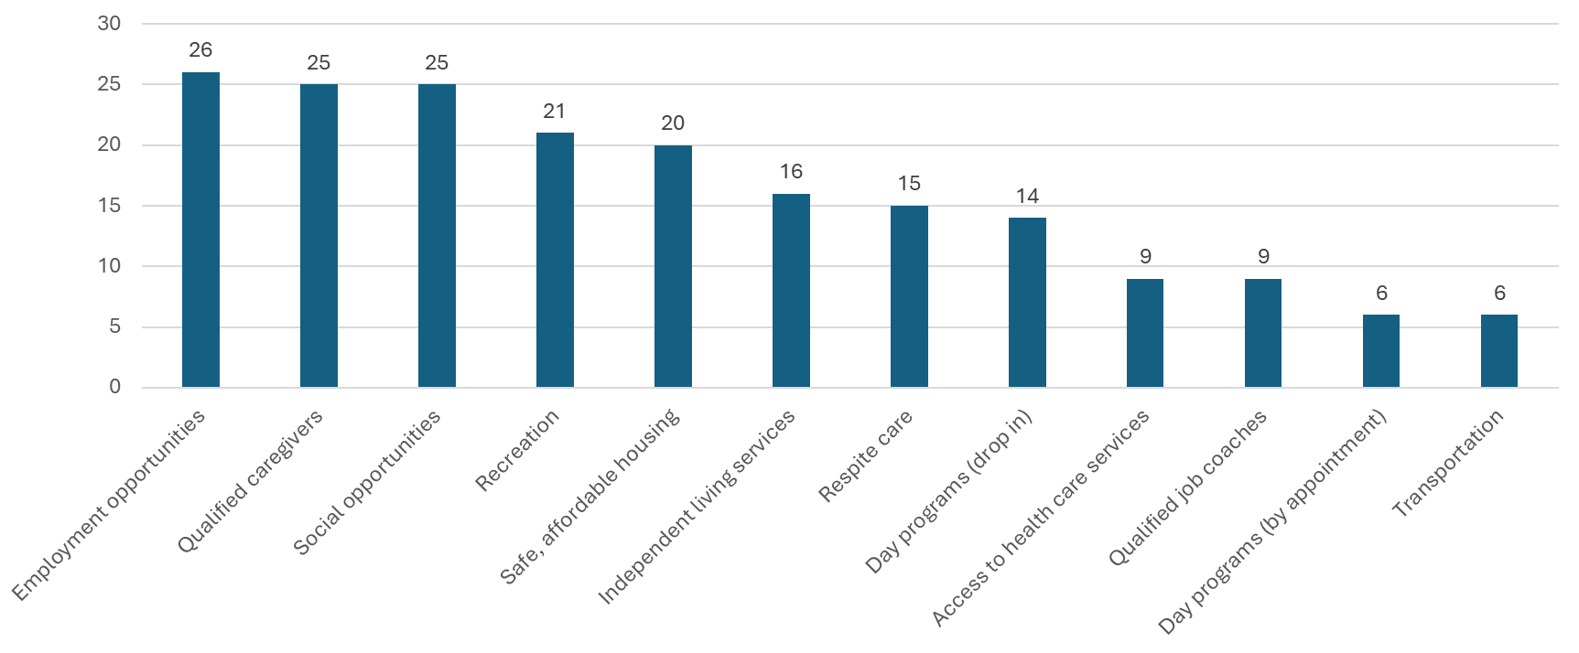

community involvement
When asked if individuals have enough supports to work or volunteer in the community, nearly 64% reported No. This is a much higher percentage than the state (39%) or the nation (36%). The most common barriers to working or volunteering for a person with intellectual or developmental disabilities were reported to be not enough jobs available, confusing system/administrative burden, not enough qualified job coaches, difficulties on the job, and transportation.
When asked what makes it hard to do things in the community, the most common barriers reported were cost, lack of support staff, stigma, and transportation.
When asked an open-ended question, “What amenities, services, or opportunities do you feel are missing in your community that would improve your quality of life or help you feel more connected with your community?”, the most common themes were social connections and community activities, caregiving/respite care, mental health services, employment, housing, transportation, and school opportunities. Housing, activities, and transportation were also common themes when asked how to improve services in Kittitas County.

caregivers & respite services
Only 35% of respondents are extremely or somewhat satisfied with access to care givers, with 49% being extremely or somewhat dissatisfied.
Nearly 25% identified respite care as one of the biggest gaps in services. Only 47% of respondents are aware of the exception to rule process for respite services. Only 22% of respondents are extremely or somewhat satisfied with access to respite services. Forty-three percent are extremely or somewhat dissatisfied.
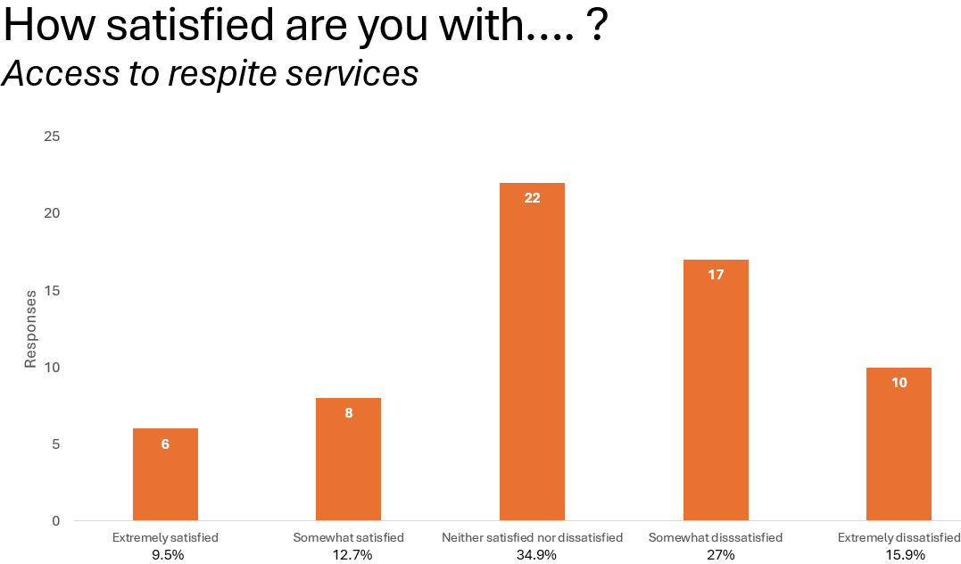

transportation
Transportation was identified as one of the main things that makes it hard to do things in the community and was a common theme when asked how to improve services in the community. Barriers to accessing public transportation include lack of knowledge, lack of comfort, cost, hours of operation, and wait times. Using transportation from friends and family members is more common than using public transportation.
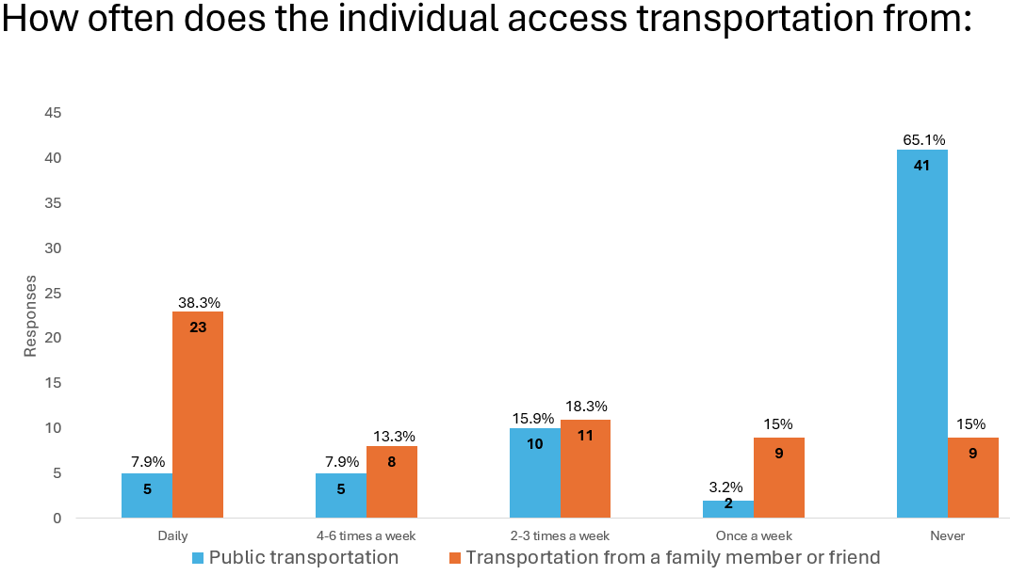

emergency preparedness
Forty percent of respondents don’t feel prepared for a medical emergency, pandemic, or natural disaster. This is considerably higher than the state at 23% and the nation at 21%. 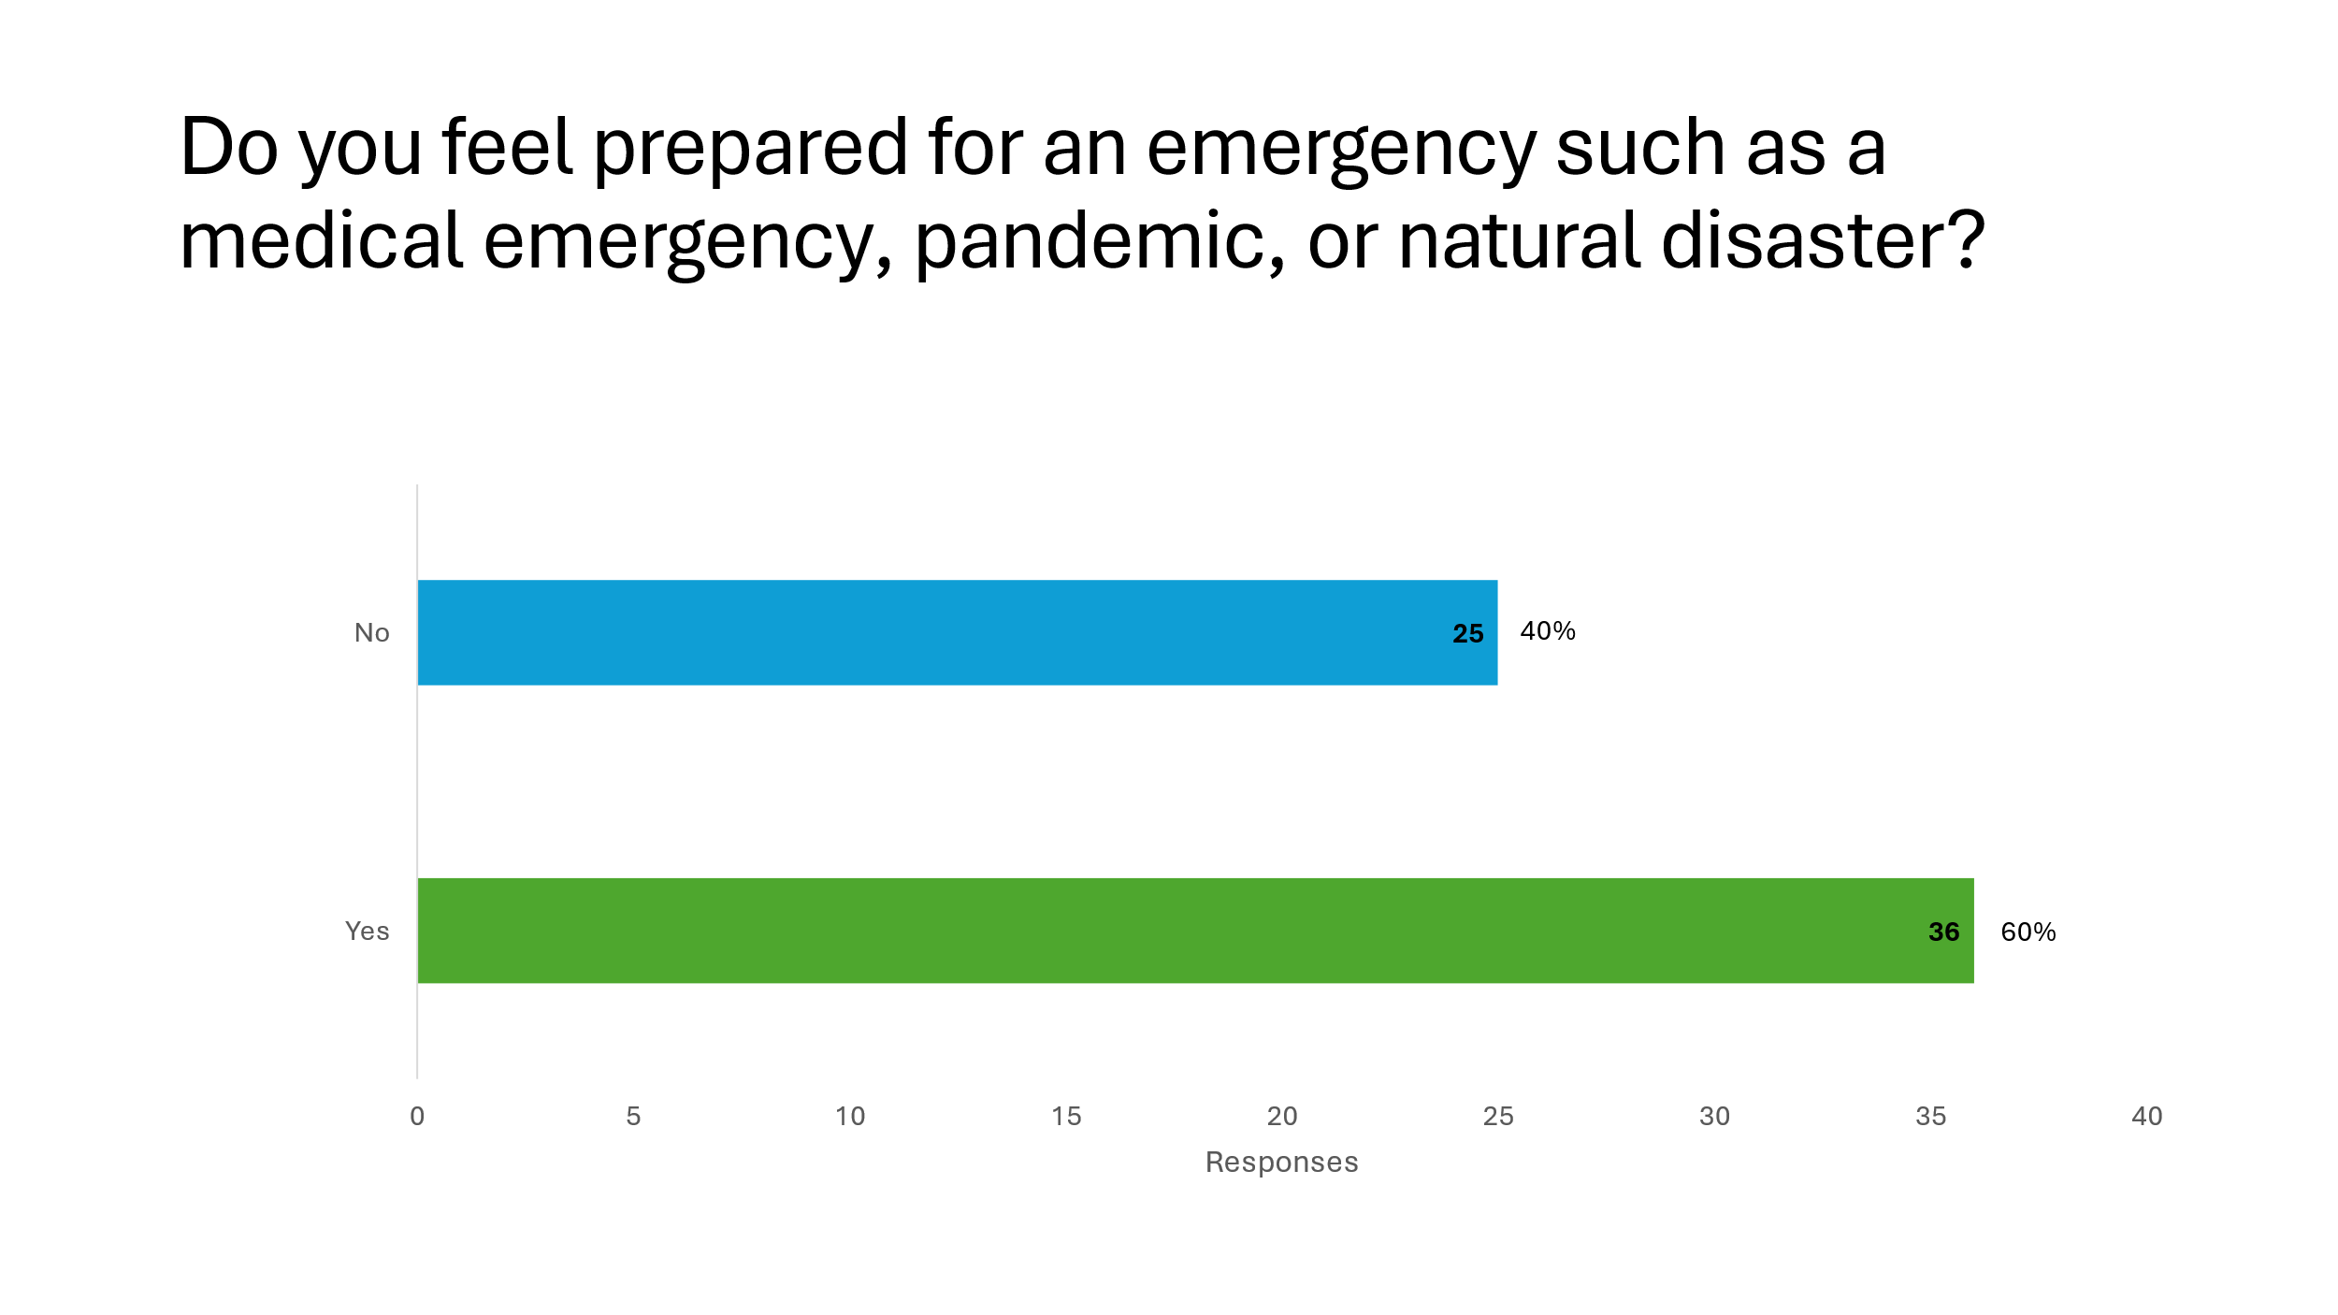

PRIORITIES
The following priorities were selected by the Kittitas County Developmental Disabilities Advisory Committee (DDAC) through a process that included facilitated brainstorming, affinity diagramming, prioritization, goal setting, and action planning. These five priorities will be utilized, not only for the DDAC, but also for funding and programmatic decisions during the biennium. Requests for funding and programs beyond the employment support services will, ideally, align with these areas.

EMPLOYMENT
There is a need in Kittitas County for more employers willing to employ people with intellectual and developmental disabilities, as well as a need for more qualified job coaches. Only 36.5% of survey respondents in Kittitas County report having enough supports to work or volunteer in the community, compared with 61% statewide and 64% nationally. Our goal is that there are sufficient vendors staffed with job coaches and enough willing employers to meet the employment needs of people with intellectual and developmental disabilities. The goal will be accomplished by engaging top employers in employing people with intellectual and developmental disabilities as well as engaging vendors in job coach recruitment and retention.

HOUSING AND SUPPORTED LIVING
Housing and supported living is a major concern for people with intellectual and developmental disabilities. Many people face uncertain futures as their parents age, supports are needed in order to be able to live as independently as possible, and people with disabilities are affected by the lack of affordable housing in Kittitas County. Our goal is that people have the opportunity and supports needed to choose their living situation. Strategies to achieve this goal include working with local governments on reducing barriers to accessory dwelling units (ADUs), researching best practices and innovative housing solutions, and distributing and inventory of housing resources available.

ACTIVITIES AND RECREATION
There is a strong need for more recreational and social activities that are inclusive of people with intellectual and developmental disabilities. Current activities are limited and people often face barriers in accessing them. Our goal is that there are accessible, affordable, and supported options for people to socialize and be involved in the community. We will work towards this goal by conducting a survey of people with intellectual and developmental disabilities to identify what they want for activities and recreation and engaging Central Washington University and local parks and recreation efforts in offering additional opportunities.

TRANSPORTATION
While transportation options are numerous for a small rural community, people with disabilities often face significant barriers to accessing transportation. Most rely on their friends and family members for transportation. Transportation was cited as one of the primary barriers to doing things in the community. Our goal is that there are options for accessible and affordable transportation besides relying on friends and family. We will advocate for easy to understand information about transportation options, communicate about transportation provided through waiver services, and work on optimizing route options.

COMMUNICATION
People with intellectual and developmental disabilities and their families face a complex system of services that can be very difficult to navigate. Improving the language we use to talk about these services can help people navigate the system easier. Our goal is that communication about resources and services is inclusive of all abilities. To help meet this goal we will put together resources about how to navigate systems and communicate about the exception to rule for accessing respite care.

IMPLEMENTATION: GOALS, STRATEGIES, OBJECTIVES, ACTIVITIES
A goal is what our desired end result is to address our priorities. The strategies are how we will accomplish our goal. The objectives provide measurable targets for strategy implementation. Finally, the activities, timeline, and who is responsible outline our action plan for making progress.

PRIORITY: EMPLOYMENT
Goal I | There are sufficient vendors staffed with job coaches and enough willing employers to meet the employment needs of people with intellectual and developmental disabilities.
Strategy A | Engage government and top employers in Kittitas County in activities that show them what it is like to employ people with intellectual and developmental disabilities.
Objectives | Engage with at least 5 employers by December 31, 2024.  Increase the number of employers employing people with intellectual and developmental disabilities by June 30, 2025.
ACTIVITIES |  | TIMELINE | WHO IS RESPONSIBLE
Identify and contact potential and current employers to participate in event (both private and government) |  | By October 2024 | DDAC
Hold employment summit event |  | By October 2024 | Kasey
Hold booths at fairs |  | By June 2025 | DDAC
Contact current employers for testimonials and potential tours/site visits |  | By March 2025 | DDAC
Gather testimonials from current employees |  | By March 2025 | DDAC
Contact vendors to identify barriers for employers |  | By March 2025 | DDAC
Create and implement marketing plan |  | By June 2025 | DDAC
Strategy B | Engage Kittitas County vendors in a conversation about barriers to job coach recruitment and retention and what might be potential solutions.
Objectives | Engage at least 2 vendors by June 30, 2026.  Identify recruitment or retention strategies to implement in next plan by June 30, 2026.
ACTIVITIES |  | TIMELINE | WHO IS RESPONSIBLE
Schedule meeting with vendors |  | By March 2026 | DDAC
Designate facilitator |  | By April 2026 | DDAC
Create agenda |  | By May 2026 | DDAC
Hold meeting |  | By June 2026 | DDAC

PRIORITY: HOUSING AND SUPPORTED LIVING
 | Goal II | People have the opportunity and supports needed to choose their living situation.
 | Strategy A | Conduct, publish, and distribute inventory of what housing resources are available for people with intellectual and developmental disabilities.
 | Objectives | Complete inventory by December 31, 2024.  Distribute through at least two different venues by June 30, 2025.
 | ACTIVITIES |  | TIMELINE | WHO IS RESPONSIBLE
 | List of partnership for housing resources |  | By October 2024 | Kasey
 | Contact long term care facilities and AFH in Kittitas County regarding housing for people with IDD |  | By November 2024 | Kasey
 | Contact housing authority |  | By November 2024 | Kasey
 | Contact Ambitions and KIM |  | By November 2024 | Kasey
 | Call 211 regarding their resource list |  | By December 2024 | Kasey
 | Use resources shown via DDA caseload report |  | By December 2024 | Kasey
 | Contact Habitat for Humanity |  | By December 2024 | Amy
 | Distribute inventory |  | By June 2025 | DDAC
 | Strategy B | Research best practices and innovative solutions in other communities for housing solutions for people with intellectual and developmental disabilities, including solutions that increase connections between people with and without disabilities.
 | Objectives | Complete research by March 31, 2025  Identify strategies to explore for Kittitas County by June 30, 2025.
 | ACTIVITIES |  | TIMELINE | WHO IS RESPONSIBLE
 | Share community homes video to DDAC |  | By December 2024 | Amy
 | Presentation for DDAC about Opportunity Village |  | By December 2024 | Amy
 | Contact DSHS for innovations/best practices |  | By December 2024 | Kasey
 | Present results of research to DDAC and identify potential strategies |  | By June 2025 | Kasey
 | Strategy C | Work with local governments in Kittitas County to advocate for decreased barriers to accessory dwelling units for families.
 | Objectives | Identify at least one barrier to address by June 30, 2026.  Communicate ADU information with families through at least 2 different venues by June 30, 2026.
 | ACTIVITIES |  | TIMELINE | WHO IS RESPONSIBLE
 | Identify permitting timeline and cost |  | By June 2025 | Rich
 | Talk with City Council to talk about why ADUs are important to people with IDD |  | By June 2025 | Amy
 | Plans specific to meet needs of residents with IDD. |  | By June 2025 | Rich
 | Create housing inventory list targeted for city council |  | By June 2025 | Kasey

PRIORITY: ACTIVITIES AND RECREATION
 | Goal III | There are accessible, affordable, and supported options for people to socialize and be involved in the community.
 | Strategy A | Engage Central Washington University and local parks and recreation departments in discussions about what they can offer in terms of opportunities for activities and recreation for people with intellectual and developmental disabilities.
 | Objectives | Engage in discussions by June 30, 2025.  Work with partners to implement at least one new activity by June 30, 2026.
 | ACTIVITIES |  | TIMELINE | PERSON RESPONSIBLE
 | Contact CWU |  | By June 2025 | DDAC
 | Contact Eburg parks and rec |  | By June 2025 | DDAC
 | Work on transportation resources |  | By December 2025 | DDAC
 | Develop schedules of activities |  | By December 2025 | DDAC
 | Find locations for activities |  | By December 2025 | DDAC
 | Identify staffing/volunteers |  | By December 2025 | DDAC
 | Get the word out/hold special events |  | By June 2026 | DDAC
 | Strategy B | Conduct survey of people with intellectual and developmental disabilities to collect more information about what they want for activities and recreation.
 | Objectives | Conduct survey with at least 25 respondents by December 31, 2025.
 | ACTIVITIES |  | TIMELINE | PERSON RESPONSIBLE
 | Create survey |  | By March 2025 | DDAC
 | Distribute survey |  | By June 2025 | DDAC
 | Analyze results |  | By September 2025 | DDAC
 | Share results with community partners |  | By December 2025 | DDAC

PRIORITY: TRANSPORTATION
 | Goal IV | There are options for accessible and affordable transportation besides relying on friends and family.
 | Strategy A | Engage Central Transit in conversations about how to best optimize route options for people with intellectual and developmental disabilities.
 | Objectives | Facilitate conversation by June 30, 2025.  Identify potential changes by June 30, 2025.
 | ACTIVITIES |  | TIMELINE | WHO IS RESPONSIBLE
 | Create map of current client locations |  | By March 2025 | DDAC
 | Invite Central Transit to DDAC meeting to understand what they are currently doing to meet needs (service map, route schedule, DD services) |  | By March 2025 | Brett or Kasey
 | Follow up action based on meeting |  | By June 2025 | DDAC
 | Strategy B | Advocate for accessible and easy to understand information about transportation options in Kittitas County.
 | Objectives | Advocate for at least one area of improvement by December 31, 2025.
 | ACTIVITIES |  | TIMELINE | WHO IS RESPONSIBLE
 | Partner with Elmview, CWDR, Ambitions, etc. to host “Ride Central Transit” afternoon |  | By June 2025 | DDAC
 | Partner with CWU computer science for app |  | By June 2025 | DDAC
 | Advocate for easy to use, interactive, speech to text app |  | By December 2025 | DDAC
 | Route maps available for people to take with them, available at lots of public places |  | By December 2025 | DDAC
 | Strategy C | Conduct communication campaign about transportation that can be provided through waiver services.
 | Objectives | Provide communication through at least 2 different venues by June 30, 2026.
 | ACTIVITIES |  | TIMELINE | WHO IS RESPONSIBLE
 | Research what is available |  | By March 2025 | DDAC
 | Condense info into easy to read 4x8 card |  | By June 2025 | DDAC
 | Social media campaign |  | By September 2025 | DDAC
 | Put info into utility bills and pass out “Ride Central Transit” day info |  | By September 2025 | DDAC
 | Have table at Farmers Market |  | By October 2025 | DDAC

PRIORITY: COMMUNICATION
 | Goal V | Communication about resources and services is inclusive of all abilities.
 | Strategy A | Put together resources for how to navigate and understand the systems for services for people with intellectual and developmental disabilities, including common terminology and acronyms.
 | Objectives | Distribute resource through at least 2 different venues by September 30, 2025.
 | ACTIVITIES |  | TIMELINE | PERSON RESPONSIBLE
 | Partner with DDA/DSHS to find out exactly what the path is |  | By March 2025 | DDAC
 | Create a “get started” guide/visual path to services using arrows and minimal language |  | By June 2025 | DDAC
 | Send guide via mail and social media |  | By September 2025 | DDAC
 | Strategy B | Conduct communication campaign about the exception to rule process for accessing additional respite care.
 | Objectives | Provide communication through at least 2 different venues by June 30, 2026.
 | ACTIVITIES |  | TIMELINE | PERSON RESPONSIBLE
 | Create flyer |  | By December 2025 | Kasey
 | Send via mail and social media |  | By June 2026 | DDAC

REFERENCES
2022. American Community Survey 5 Year Estimates. Accessed February 2024. https://data.census.gov/table/ACSST5Y2022.S2301?q=acs%202022&t=Employment&g=050XX00US53037.
April 1, 2023. Population of Cities, Towns, and Counties. Washington State Office of Financial Management. Accessed December 18, 2023. https://ofm.wa.gov/washington-data-research/population-demographics/population-estimates/april-1-official-population-estimates.
U.S. Census Bureau. 2020. Kittitas County Profile. Accessed January 2024. https://data.census.gov/profile/Kittitas_County,_Washington?g=050XX00US53037.
University of Wisconsin Population Health Institute. 2023. County Health Rankings & Roadmaps. Accessed December 18, 2023. https://www.countyhealthrankings.org/explore-health-rankings/washington/kittitas?year=2023.
Washington State Developmental Disabilities Administration. 2020. "Developmental Disabilities Administration 2020 Caseload and Cost Report." Washington State Department of Social and Health Services. Accessed September 6, 2021. https://www.dshs.wa.gov/sites/default/files/DDA/dda/documents/2020%20DDA%20Caseload%20and%20Cost%20Report.pdf.
Washington State Developmental Disabilities Administration. 2023. "Report to Advocates & Stakeholders: 2023 Caseload and Cost Report." Accessed 2024.
Washington State Developmental Disabilities Administration. 2021. "Strategic Plan Metrics 2021-2023." Washington State Department of Social and Health Services. Accessed July 25, 2021. https://www.dshs.wa.gov/data/metrics/DDA.pdf.
Washington State Division of Vocational Rehabiltation. 2017. "Disability & DVR Statistics Report." Accessed July 25, 2021. https://www.dshs.wa.gov/sites/default/files/dvr/pdf/2017%20Disability%20%26%20DVR%20Statistics%20Report.pdf.
Washington State Divsion of Vocational Rehabilitation. 2022. "Comprehensive Statewide Needs Assessment." Accessed February 2024. https://www.dshs.wa.gov/sites/default/files/dvr/CSNA-Combined-Report-Final-revised-with-footnotes-10-9-23.pdf.
Washington State Office of Superintendent of Public Instruction. 2024. Washington State Report Card. Accessed February 2024. https://washingtonstatereportcard.ospi.k12.wa.us/ReportCard/ViewSchoolOrDistrict/103300.

APPENDIX A: ELIGIBILITY FOR DDA SERVICES
Individuals who want to participate in Employment and Day Programs must be eligible to be on a Waiver Program through DDA that provides employment funding. Funding for these services comes through a federal program under Title XIX Medicaid called the Home and Community-Based Services (HCBS) Waivers. The HCBS waivers allow the state to use Medicaid funding while “waiving” Medicaid rules that require services to be provided in an institutional setting. The purpose of the waivers is to provide integrated, community-based services to individuals with developmental disabilities. Waivers Provide an alternative to institutional services. To assist consumers in selecting the right Waiver Program, a description of the Waiver Programs and the services provided under each program is listed on the following page.

WHO IS ELIGIBLE FOR A WAIVER PROGRAM?

Eligibility for waiver services includes people with developmental disabilities who:
- Are clients of DSHS Developmental Disabilities Administration (DDA),
- Meet disability criteria established by the Social Security Administration (SSA),
- Are eligible for Medicaid services in an institution,
- Have been determined to need home and community-based services in order to live in the community, and
- Have an individual gross income that does not exceed 300 percent of the Supplement Security Income benefit amount and individual resources that do not exceed $2,000 (Parental income is not considered for children.)

TYPES OF WAIVER PROGRAMS

BASIC PLUS WAIVER
This waiver program is for people who live with their families, on their own, in an adult family home, in another setting with assistance or an Adult Residential Care Assisted Living Facility (ARC) and are at high risk of out-of-home placement. Services covered include the following:
- Hours per year available for Supported Employment or Community Access, based on DDA assessment and employment status.
- Up to $6,192 is available for any combination of Skilled Nursing (Nursing Delegation); Community Guide; Environmental Accessibility; Adaptations; Specialized Medical Equipment/Supplies; Occupational Therapy; Specialized Psychiatric Services; Physical Therapy; Speech, Hearing and Language Services; Staff/Family Consultation and Training; Behavioral Health Stabilization; and Transportation to a Waiver Service.
- Behavioral Health Stabilization Services
- Respite is based on assessed need.
- $6,000 per year available for Emergency Assistance.

CORE WAIVER
This waiver is intended for people who are at immediate risk of out-of-home placement and need up to 24-hour residential services. Services covered include: Residential Services, Behavior Support, Therapies, Environmental Adaptations, Skilled Nursing, Employment services, Specialized Medical Equipment and Supplies and more.

COMMUNITY PROTECTION WAIVER
This waiver is for people who need 24-hour on-site awake staff supervision and therapies to maintain their own and community safety. Services covered include: Residential Services, Behavior Support, Therapies, Environmental Adaptations, Skilled Nursing, Employment services, Specialized Medical Equipment and Supplies and more.

INDIVIDUAL & FAMILY SERVICES WAIVER (IFS)
This waiver became effective June 1, 2015, and offers support to clients living with a family member in the community. The intent of this program is to provide support and services to family members, centered on the needs of the client and the family. Services covered include the following:
- IFS funding levels range from $1,200 to $3,600, depending on assessed need (determined by assessment).
- IFS services include Respite; Behavior Support and Consultation; Community Engagement; Home and Vehicle Modifications; Peer Mentoring; Assistive Technology and Speech; Occupational, and Physical Therapies; Person Centered Plan Facilitation; Specialized clothing and nutrition; Skilled Nursing; and Transportation to a Waiver Service.
- IFS services can be used in any combination, not to exceed a client’s annual allocation.

CHILDREN’S INTENSIVE IN-HOME BEHAVIORAL SUPPORT (CIIBS)
This waiver combines wrap-around planning with positive behavior supports to empower families to remain together. To be eligible for CIIBS, your child must be between the ages 8 through 20 years old living with their family and are assessed at high or severe risk of out-of-home placement due to challenging behaviors. Services covered are determined by the Individual Support Plan with an average cost of service, including respite, of $4,000 per month per client for any combination of the following services: Skilled Nursing, Nurse Delegation and Behavior Support and Consultation; Environmental Accessibility Adaptations; Assistive Technology; Therapeutic Equipment and Supplies; Specialized Medical Equipment/Supplies; Specialized Nutrition and clothing; Vehicle Modifications; Occupational Therapy; Specialized Psychiatric Services; Physical Therapy; Speech, Hearing and Language Services; Staff/Family Consultation and Training; and Transportation.

ACCESSING WAIVER SERVICES
STEP 1
In order to access county funded services, individuals with developmental disabilities must be determined eligible for services through the Developmental Disabilities Administration (DDA). To apply for DDA services in our area eligibility paperwork can be requested from the following number, email or web address:

Toll Free: 1-866-715-3646
Email: R1ServiceRequestB@dshs.wa.gov
Website: https://www.dshs.wa.gov/dda/service-and-information-request

STEP 2
Once an individual has been determined eligible for DDA services and has been assigned to a Case Resource Manager (CRM), a person-centered DDA assessment will be completed. The assessment determines what services a person may be eligible for. If certain criteria are met, a request to be placed on a Waiver Program can be made. There are a variety of resources available through the Waiver Programs and the case resource manager will help guide a person in selecting the appropriate Waiver Program that includes employment and day services.
STEP 3
After a person has been determined eligible for a waiver program that offers employment services, their assigned case resource manager will provide information about local employment vendors. It is recommended that the person seeking services and their family representatives take time to meet with local providers to determine which provider is going to be the best fit. Once a person has selected their employment provider, the employment provider will start the intake and discovery process to start them on their pathway to employment.

APPENDIX B: KITTITAS COUNTY SERVICES

B HEARD B STRONG B PROUD
Ellensburg, WA 98926
Phone: 509-607-4470
Website: https://www.facebook.com/BHeardBStrongBProud17/, https://bheardbstrongbproud.wordpress.com/

CENTRAL WASHINGTON DISABILITY RESOURCES
301 East 2nd Avenue
Ellensburg, WA 98926
Phone: 509-962-9620
Website: http://mycwdr.org

CHILDREN’S VILLAGE
3801 Kern Rd.
Yakima, WA 98902
Phone: 509-574-3200
Website: https://www.yakimachildrensvillage.org/our-services.asp

CHILDREN WITH SPECIAL HEALTHCARE NEEDS PROGRAM
Community Health of Central Washington
521 E Mountain View Ave
Ellensburg, WA 98926
Phone: 509-306-1740
Website: https://www.chcw.org/stepscyshcn-children-special-health-care/

CLE ELUM ROSLYN SCHOOL DISTRICT SPECIAL PROGRAMS
2960 SR 903
Cle Elum, WA 98922
Phone: 509-649-4807
Website: https://www.cersd.org/page/special-programs

DEVELOPMENTAL DISABILITIES ADMINISTRATION
100 East Jackson Avenue, Suite 100
Ellensburg, WA 98926
Phone: 509-925-0405
Website: https://www.dshs.wa.gov/dda

DIVISION OF VOCATIONAL REHABILITATION
100 East Jackson Avenue, Suite 100
Ellensburg, WA 98926
Phone: 509-925-0408
Website: https://www.dshs.wa.gov/dvr

EASTON SCHOOL DISTRICT SPECIAL EDUCATION SERVICES
1893 Railroad Street/PO Box 8
Easton, WA 98925
Phone: 509-656-2317
Website: http://www.easton.wednet.edu

ELLENSBURG SCHOOL DISTRICT SPECIAL EDUCATION SERVICES
1300 East 3rd Avenue
Ellensburg, WA 98926
Phone: 509-925-8117
Website: https://www.esd401.org/students-families/student-services/special-services

ELMVIEW
204 East 6th Avenue
Ellensburg, WA 98926
Phone: 509-925-6688
Website: https://www.elmview.org

ENTRUST COMMUNITY SERVICES
415 East Mt. View Avenue, Suite 301
Ellensburg, WA 98926
Phone: 509-925-6688
Website: https://www.elmview.org

HOPESOURCE-ELLENSBURG
700 E Mountain View, Suite 501
Ellensburg, WA 98926
Phone: 509-925-1448
Website: http://www.hopesource.us

HOPESOURCE-CLE ELUM
110 Pennsylvania Ave
Cle Elum, WA 98922
Phone: 509-674-2375
Website: http://www.hopesource.us

KITTITAS COUNTY DEVELOPMENTAL DISABILITIES PROGRAM
Kittitas County Public Health Department
507 N. Nanum St. Suite 102
Ellensburg, WA 98926
Phone: 509-933-8233
Website: https://www.co.kittitas.wa.us/health/community/developmental-disabilities.aspx

KITTITAS COUNTY HEALTH NETWORK
110 W. 6th Ave, #393 (mailing)
Ellensburg, WA 98926
Phone: 509-933-7544
Website: https://healthierkittitas.org/dda-services

KITTITAS SCHOOL DISTRICT SPECIAL EDUCATION SERVICES
7571 Kittitas Hwy
Kittitas, WA 98934
Phone 855-380-8843
Website: https://www.ksd403.org/page/special-education

PARENT TO PARENT AND PARENT COALITION
Kittitas Valley Opportunities
Phone: 509-929-7277
Website: https://kc-p2p.wixsite.com/home

SEEDLINGS CENTERS FOR EARLY LEARNING
220 East Helena Avenue
Ellensburg, WA 98926
Phone: 509-872-5132
Website: https://www.epicnet.org/

SOCIAL SECURITY ADMINISTRATION
801 Fruitvale Blvd.
Yakima, WA 98902
Phone: 800-772-1213
Website: https://www.ssa.gov/

SPIRIT THERAPEUTIC RIDING CENTER
1051 Sorenson Road
Ellensburg, WA 98926
Phone: 509-929-1401
Website: http://www.spirittrc.com/

TRELLIS CENTER
170 Bare Rd
Ellensburg, WA 98926
Phone: 509-968-4040
Website: http://www.thetrelliscenter.com/

APPENDIX C: COMMUNITY SURVEY RESULTS
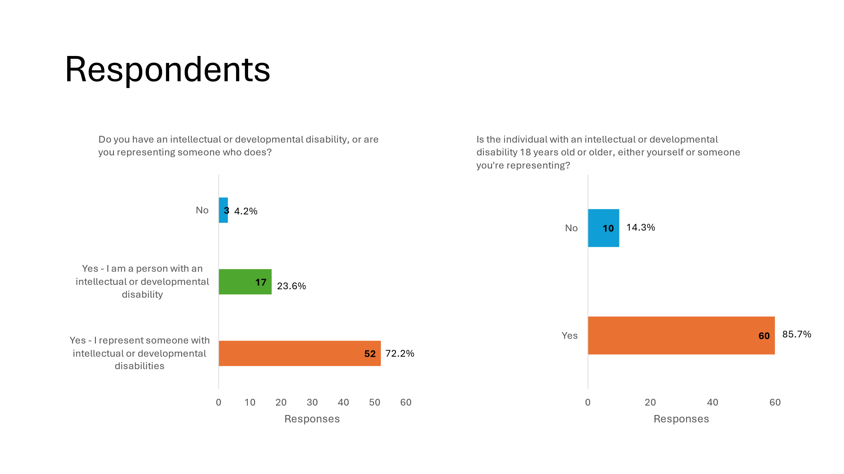
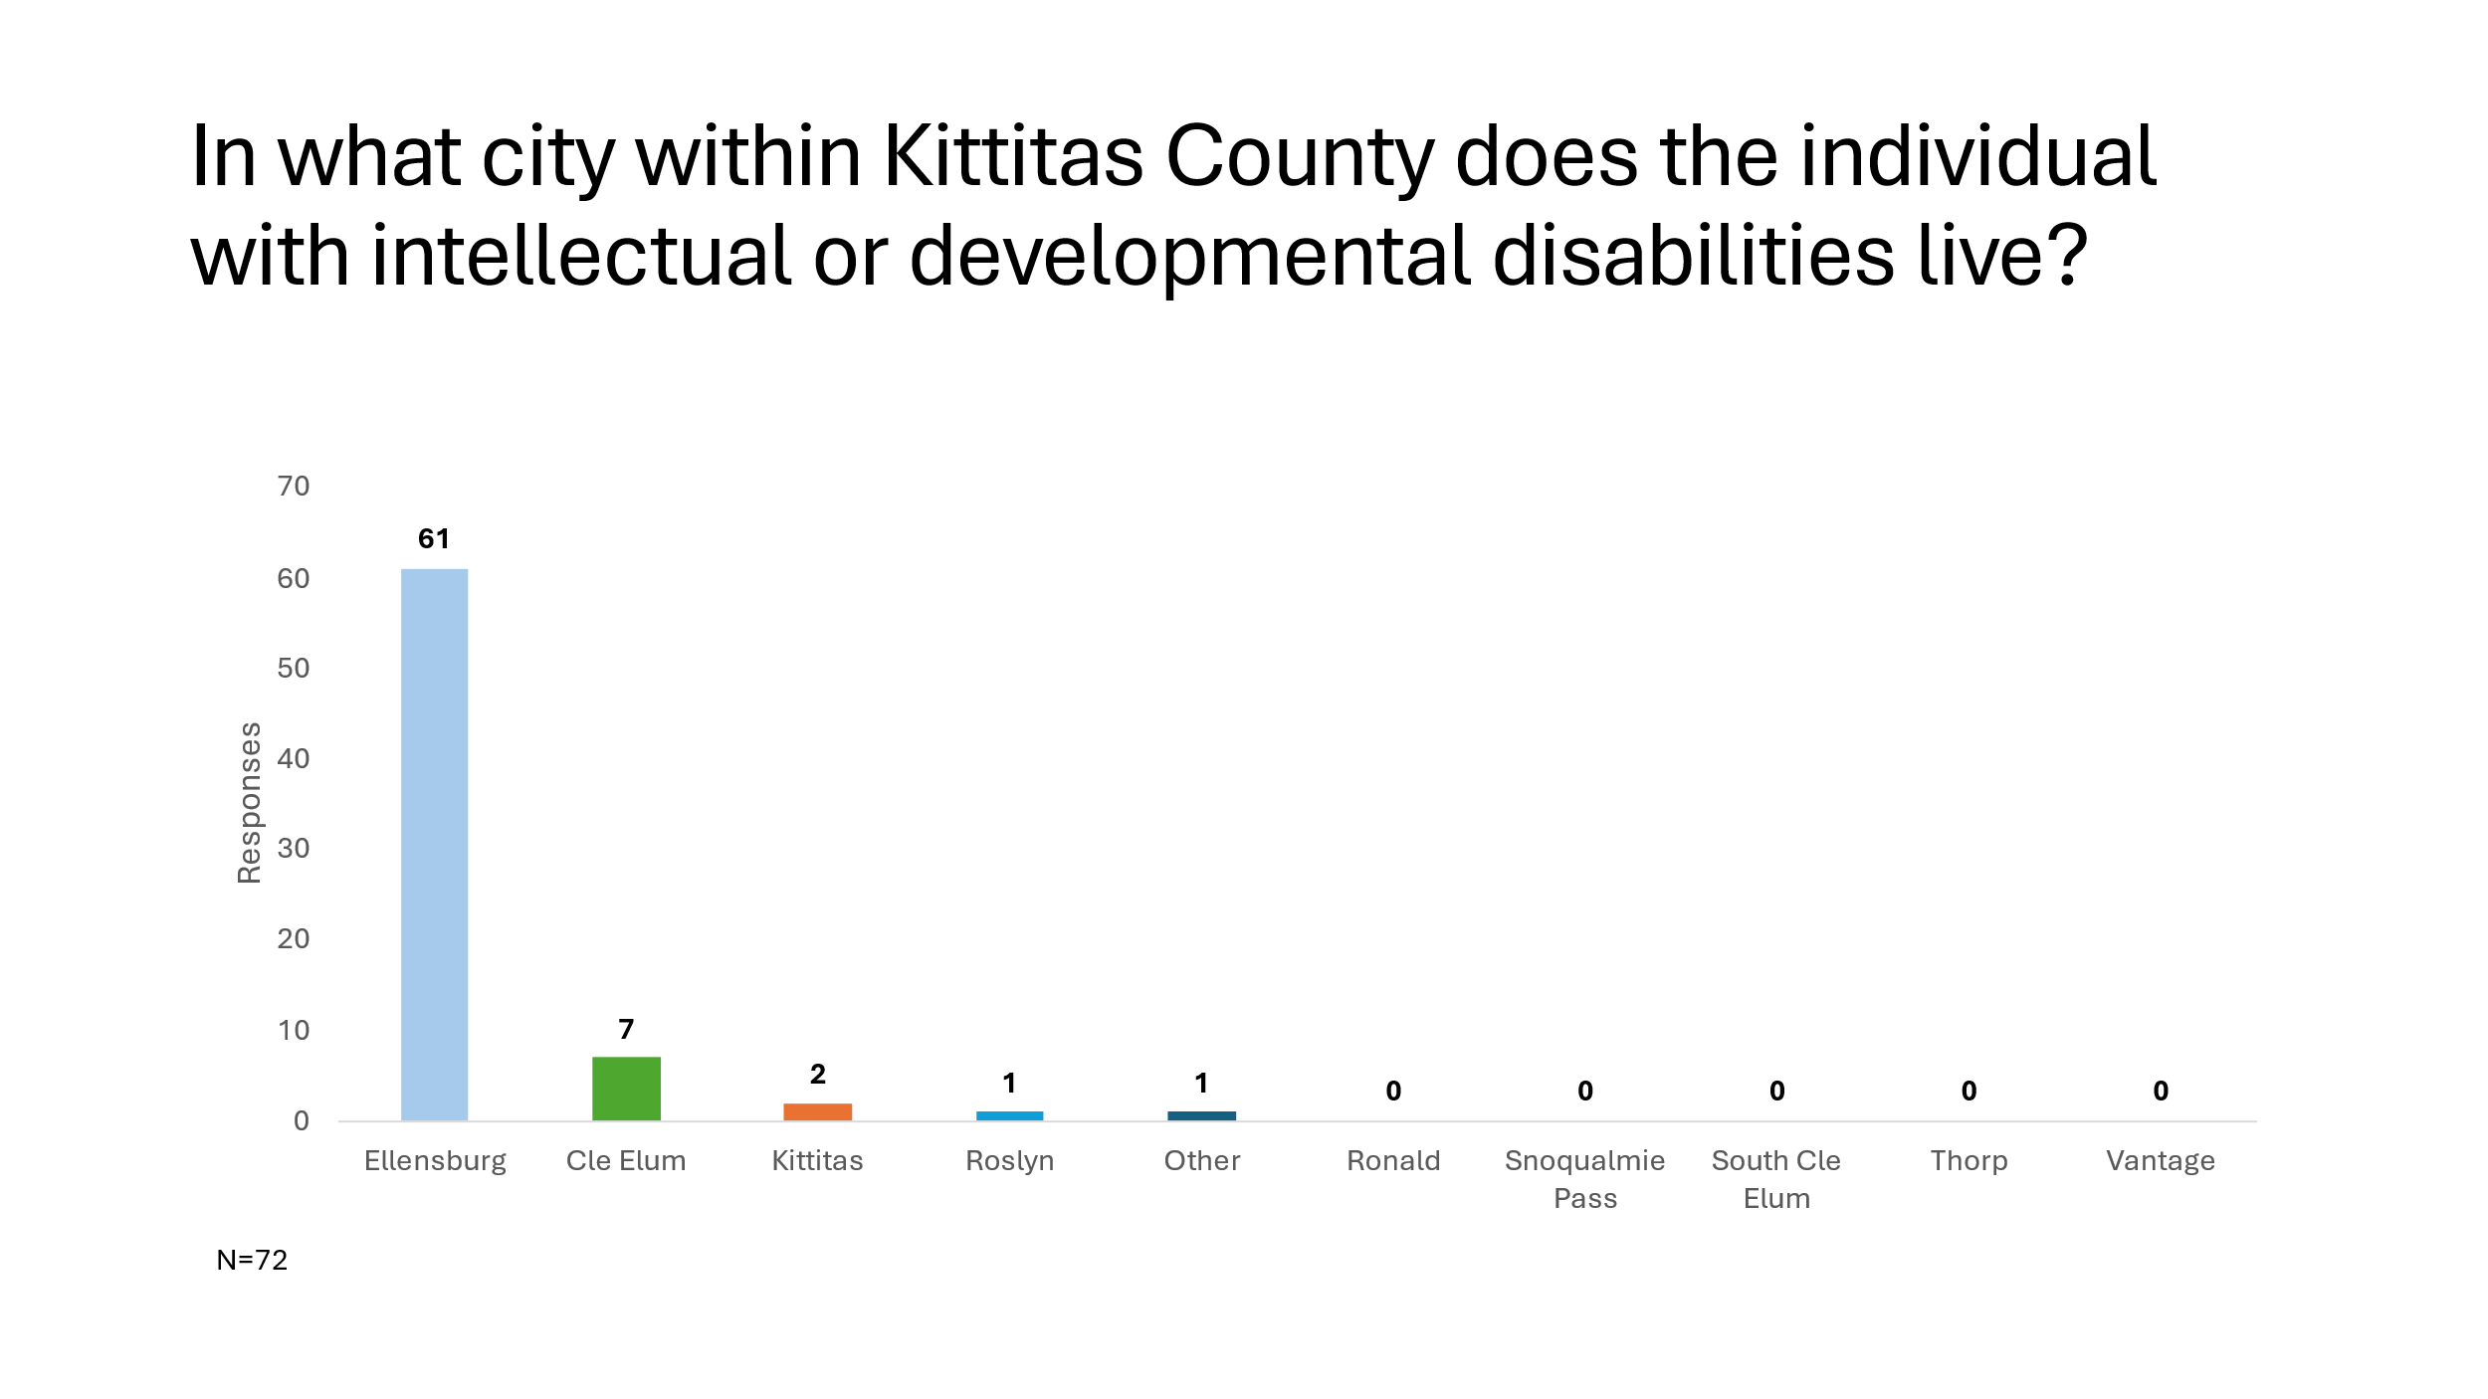
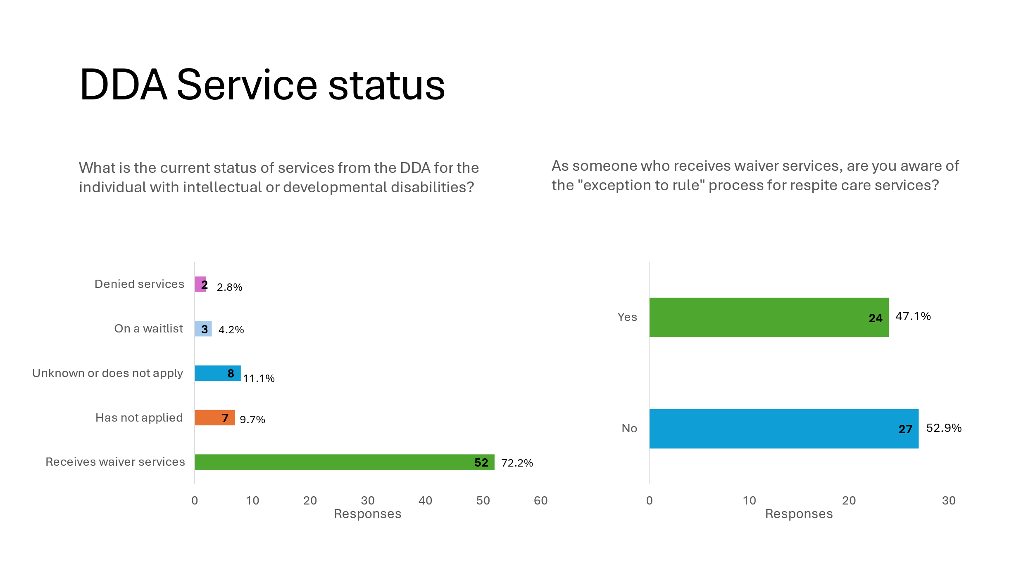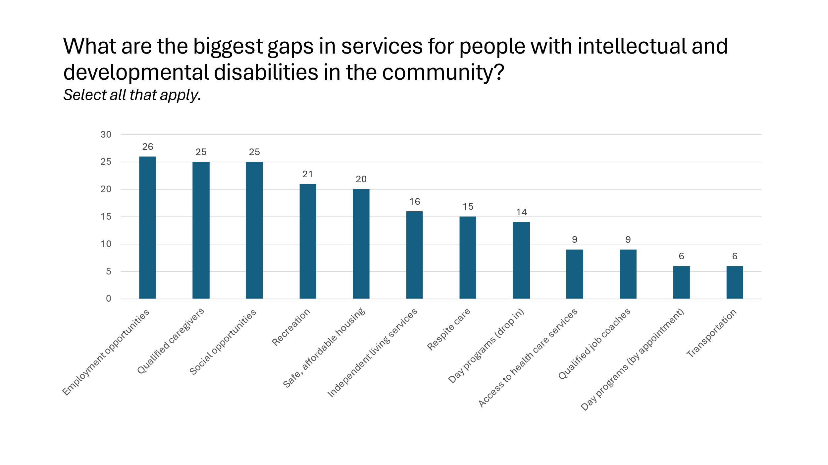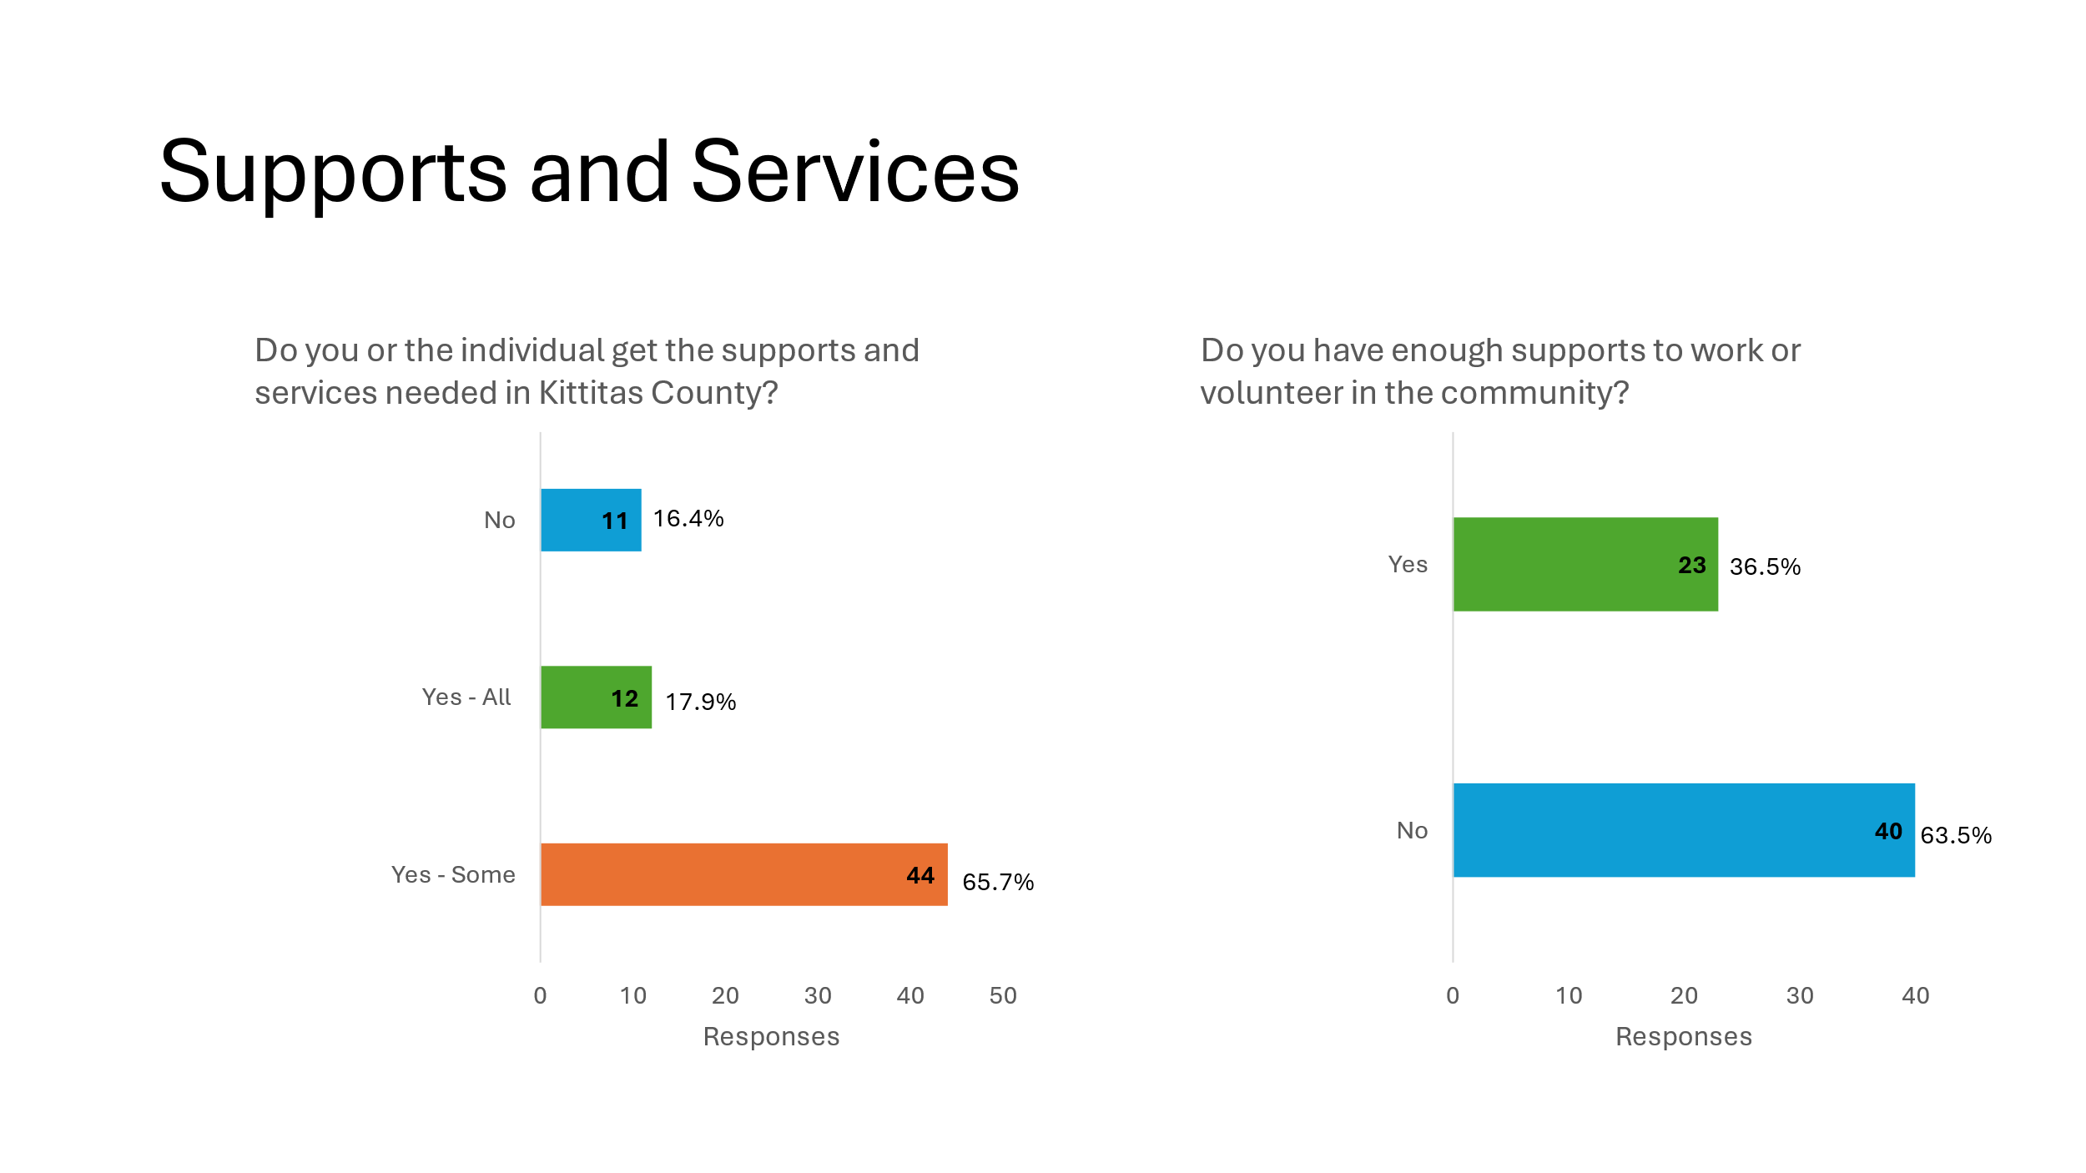
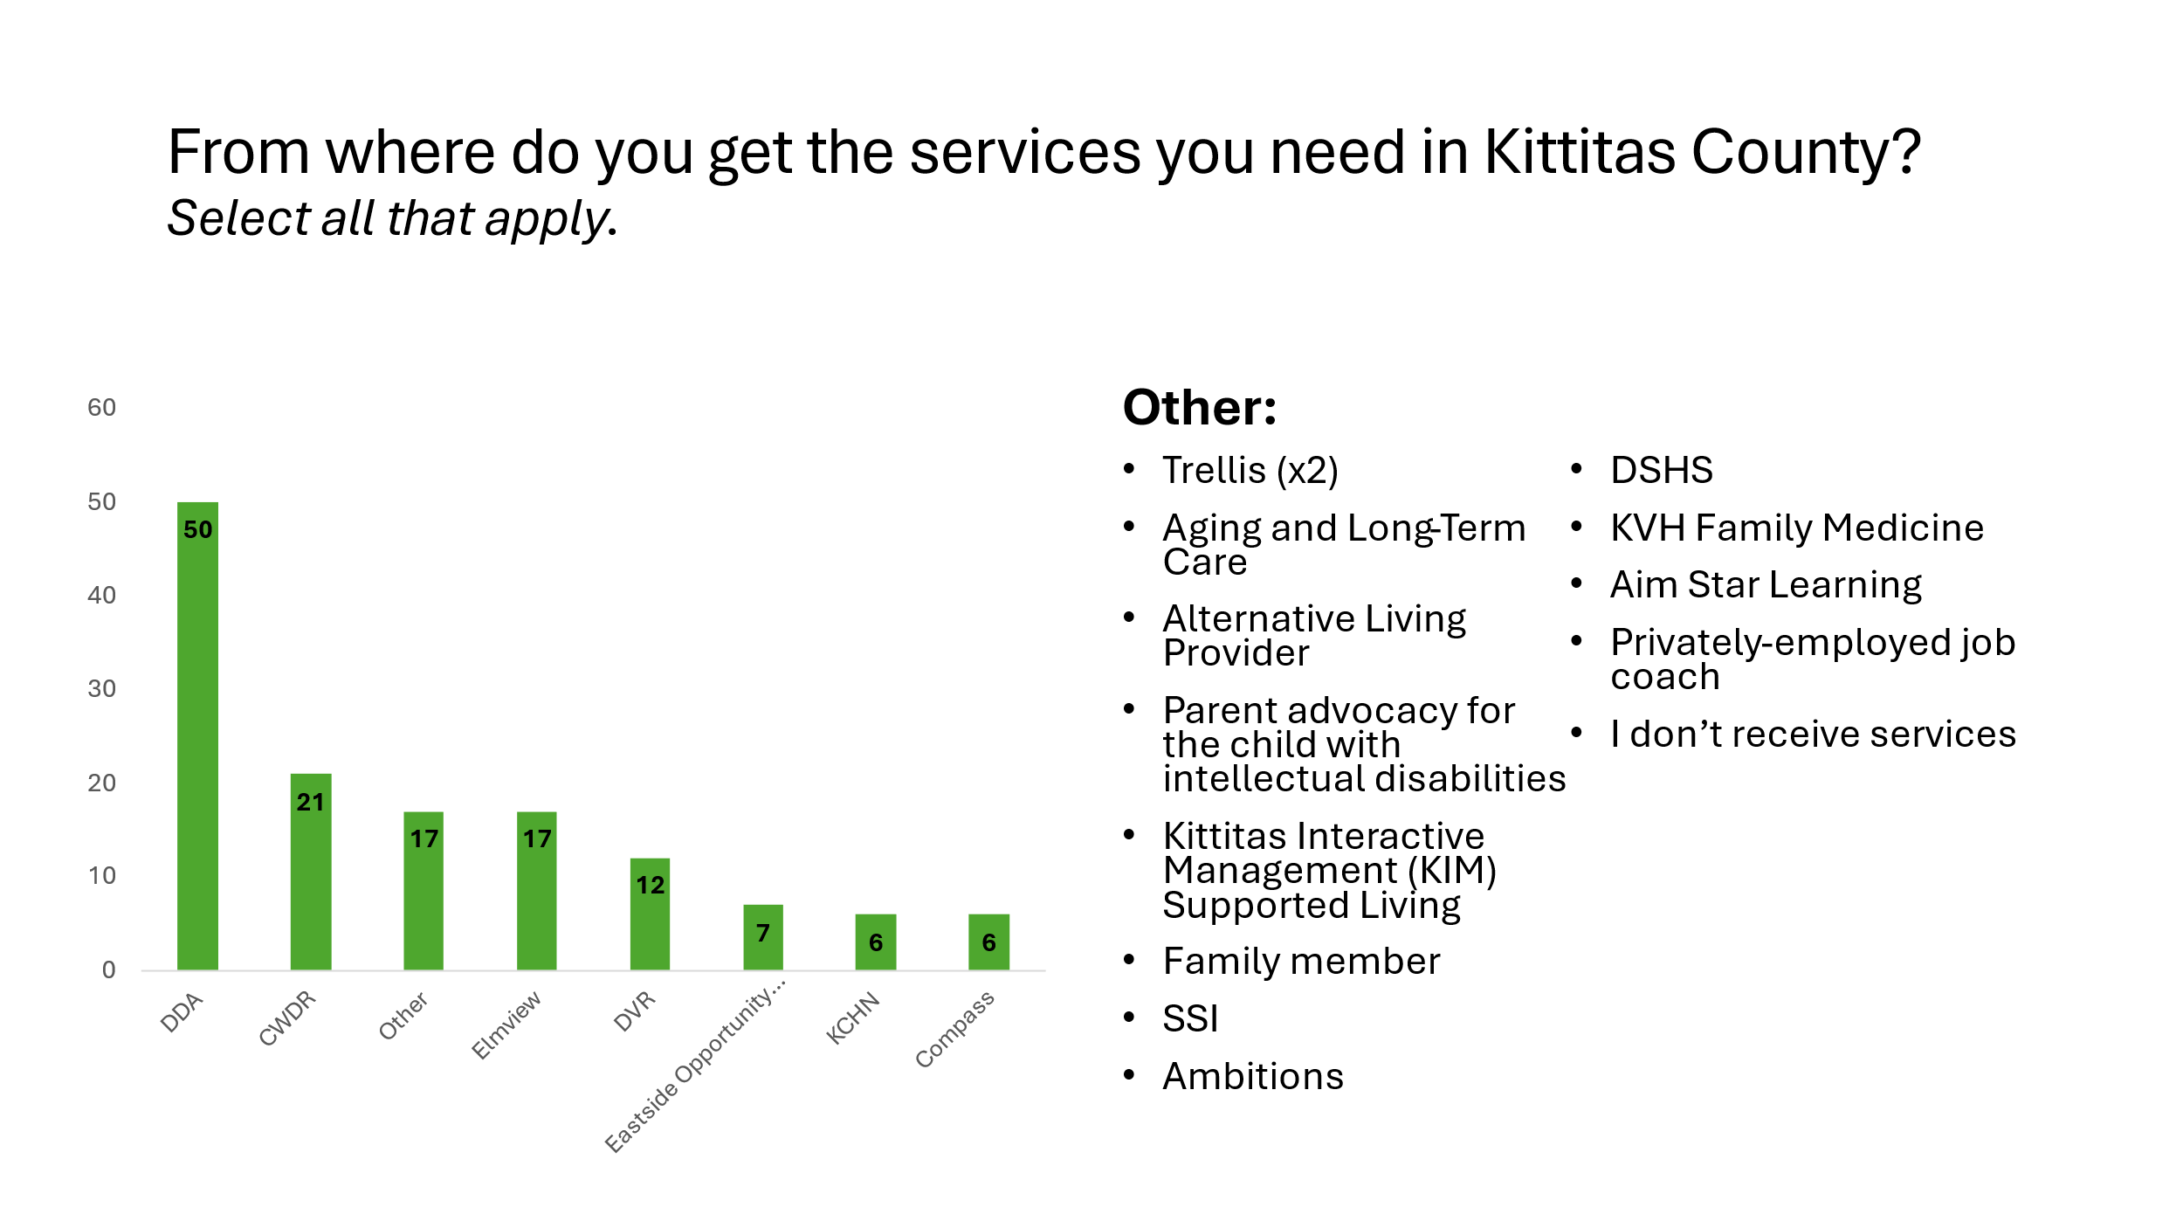
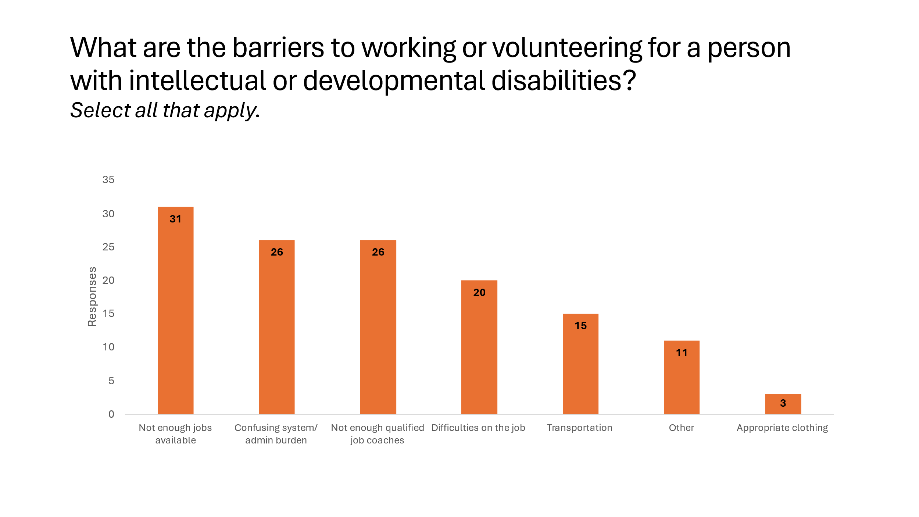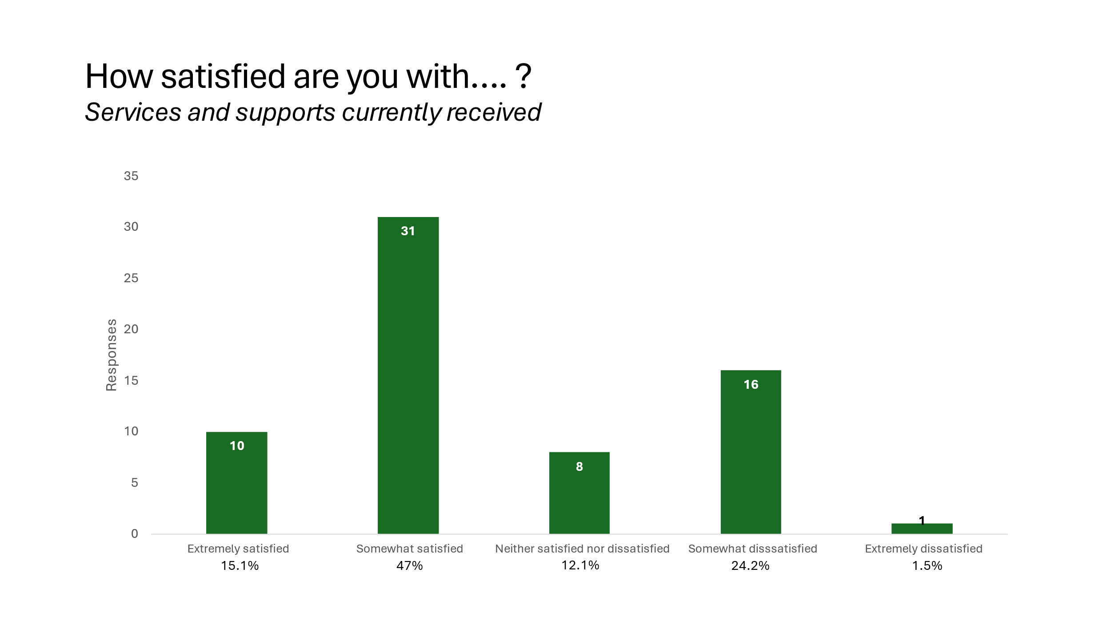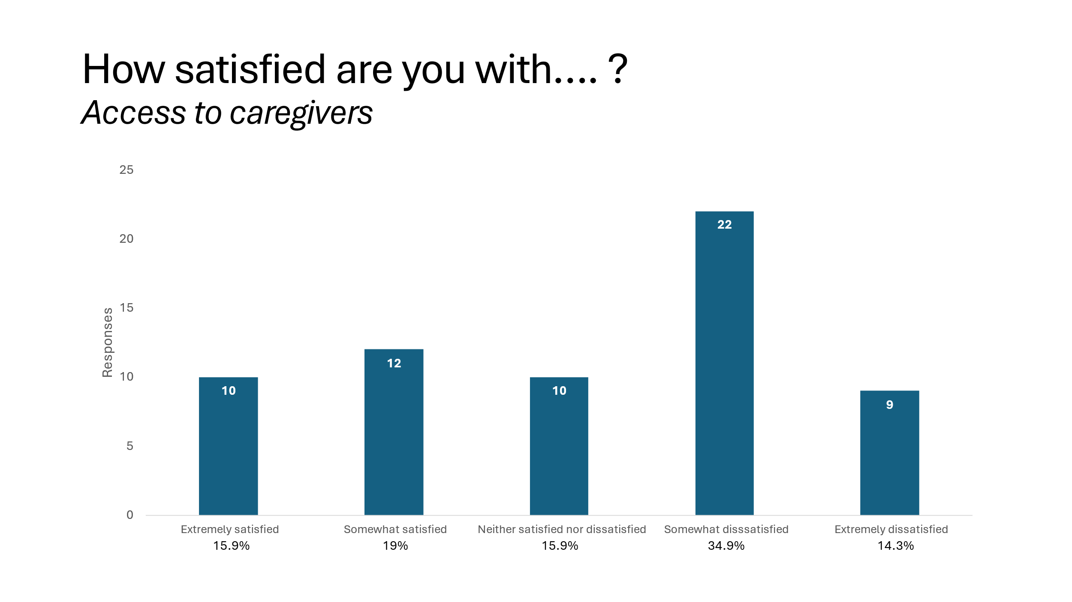
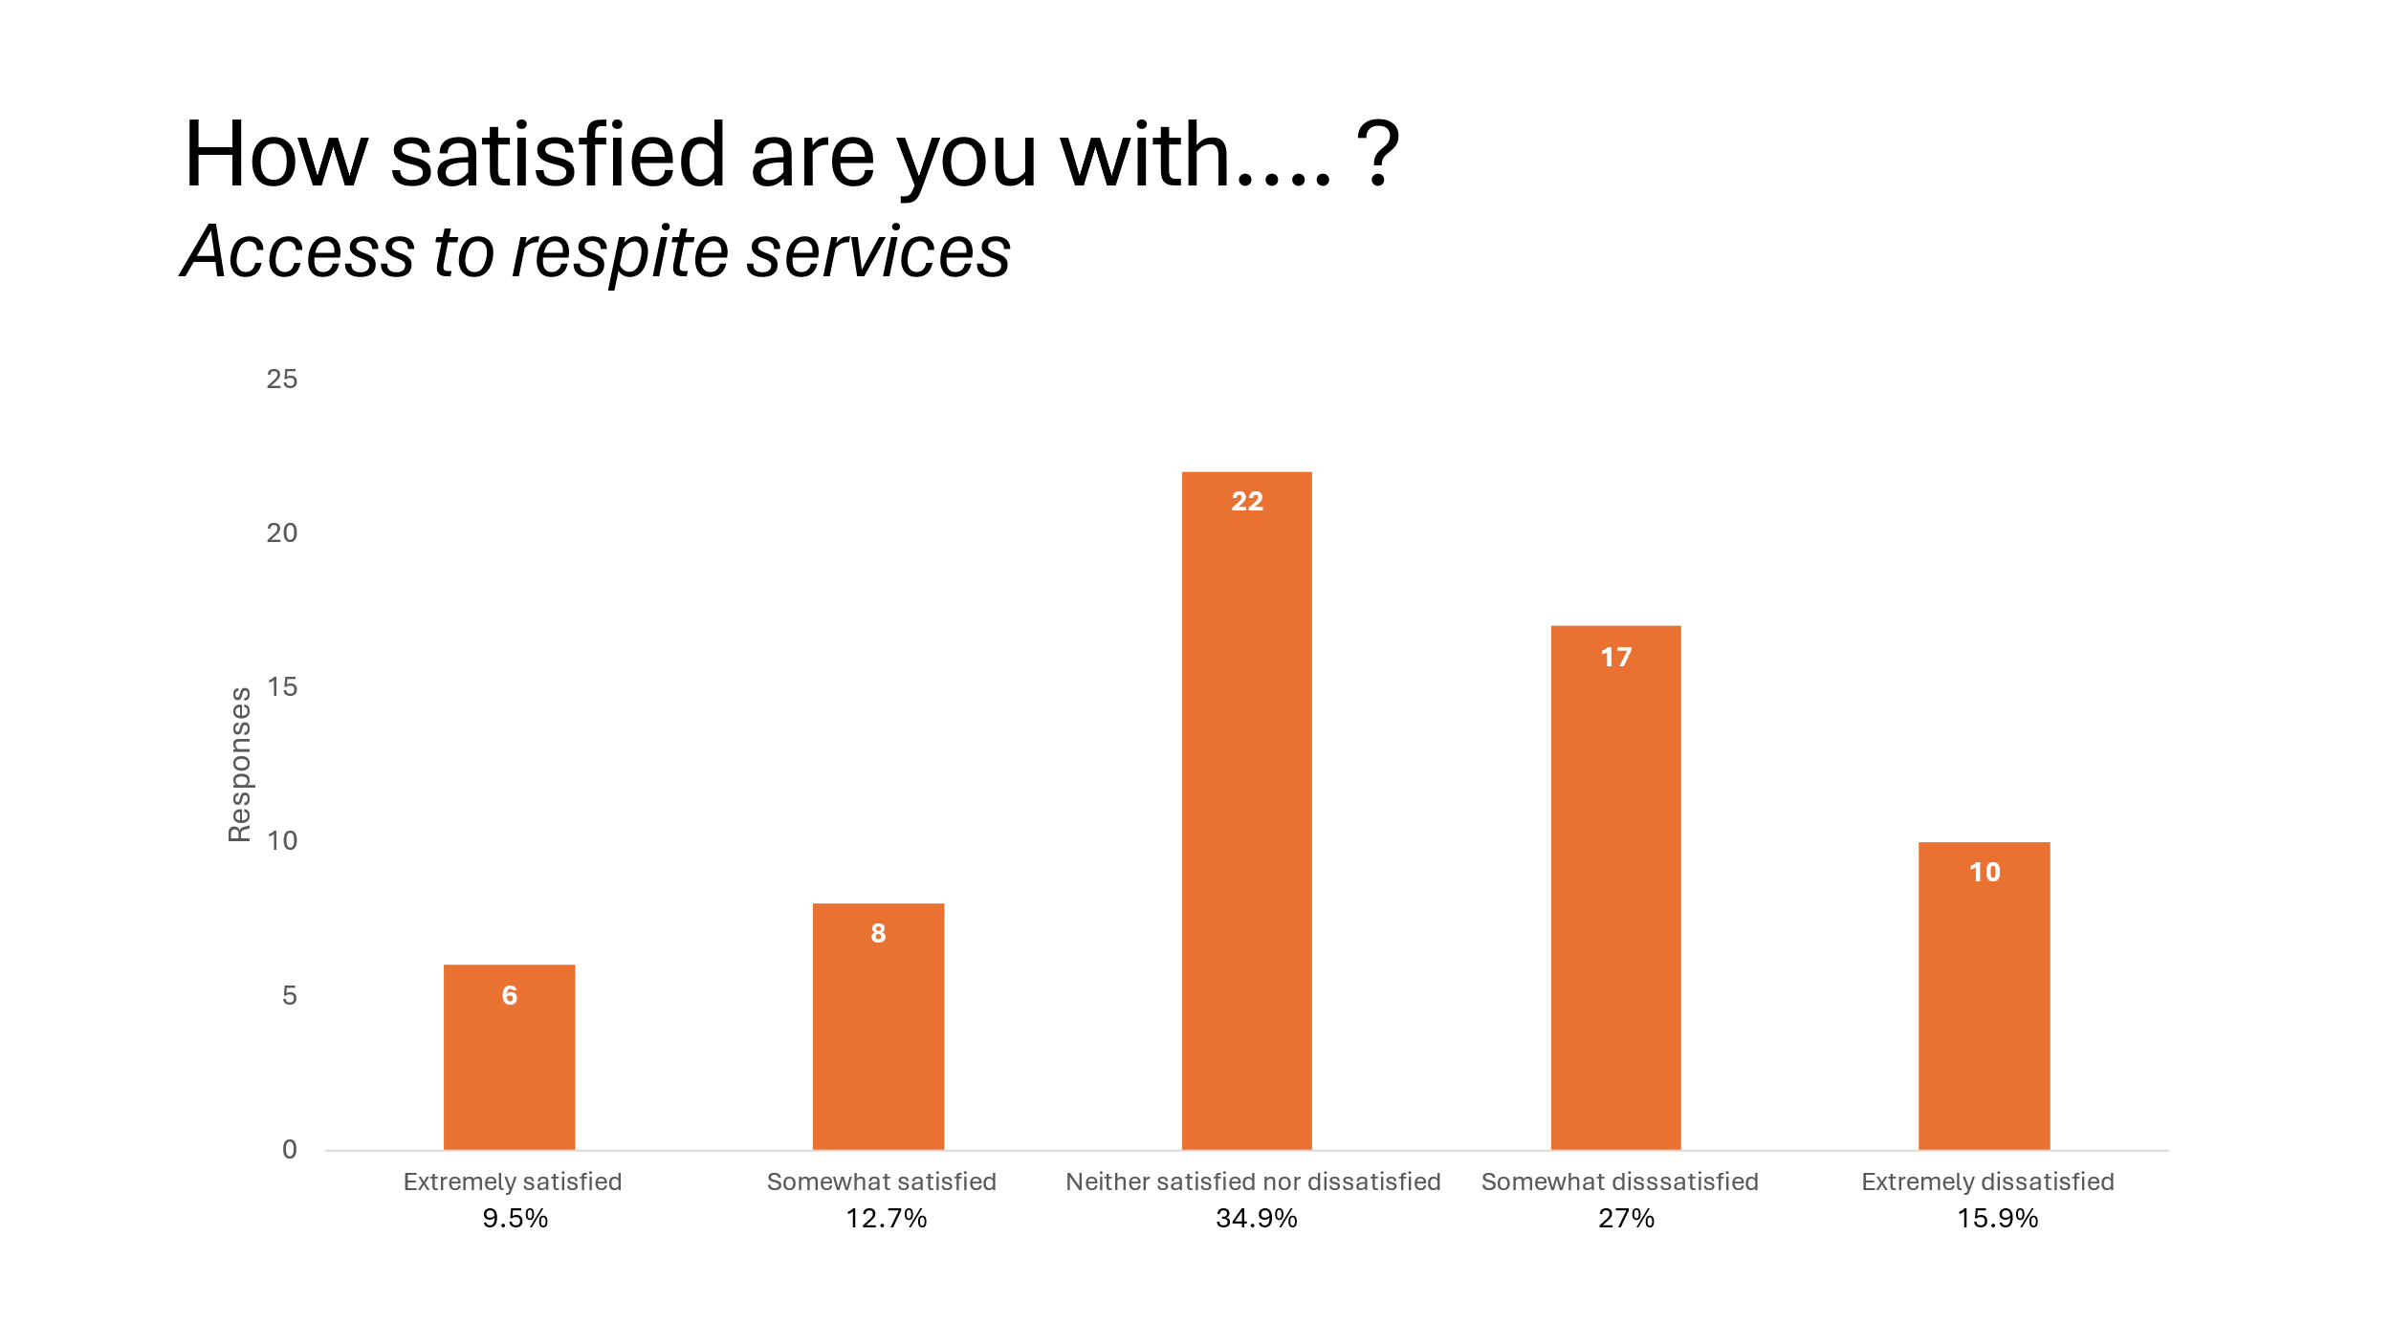
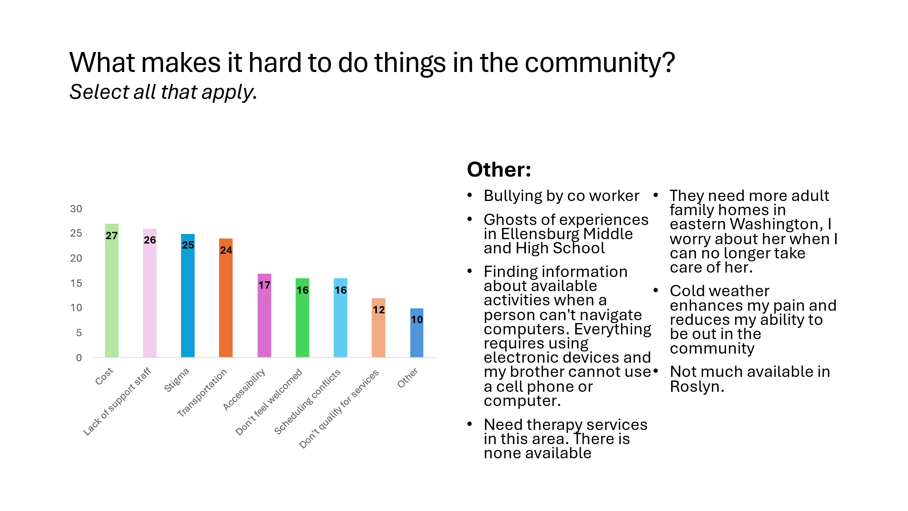
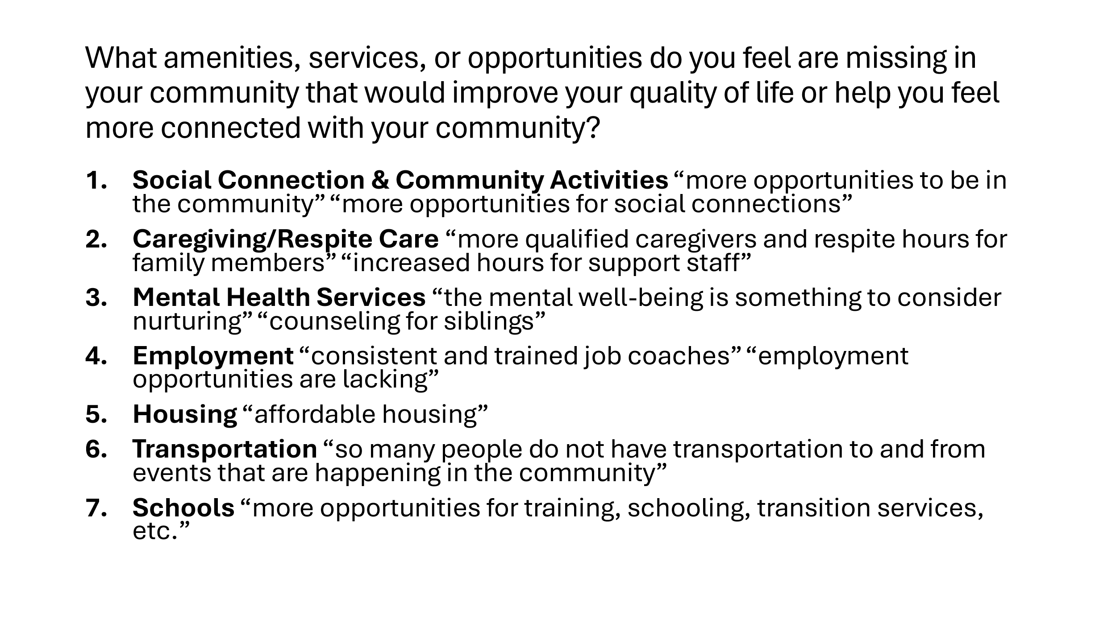
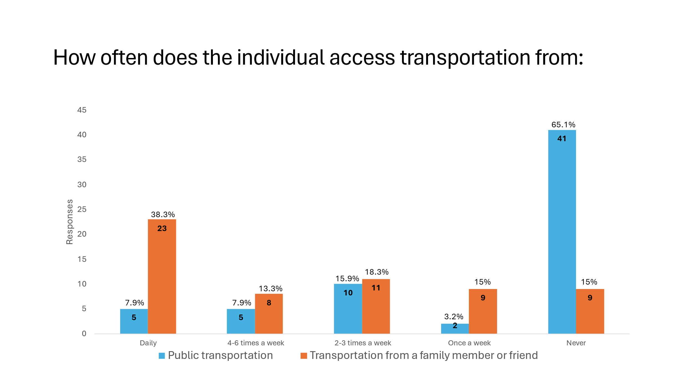
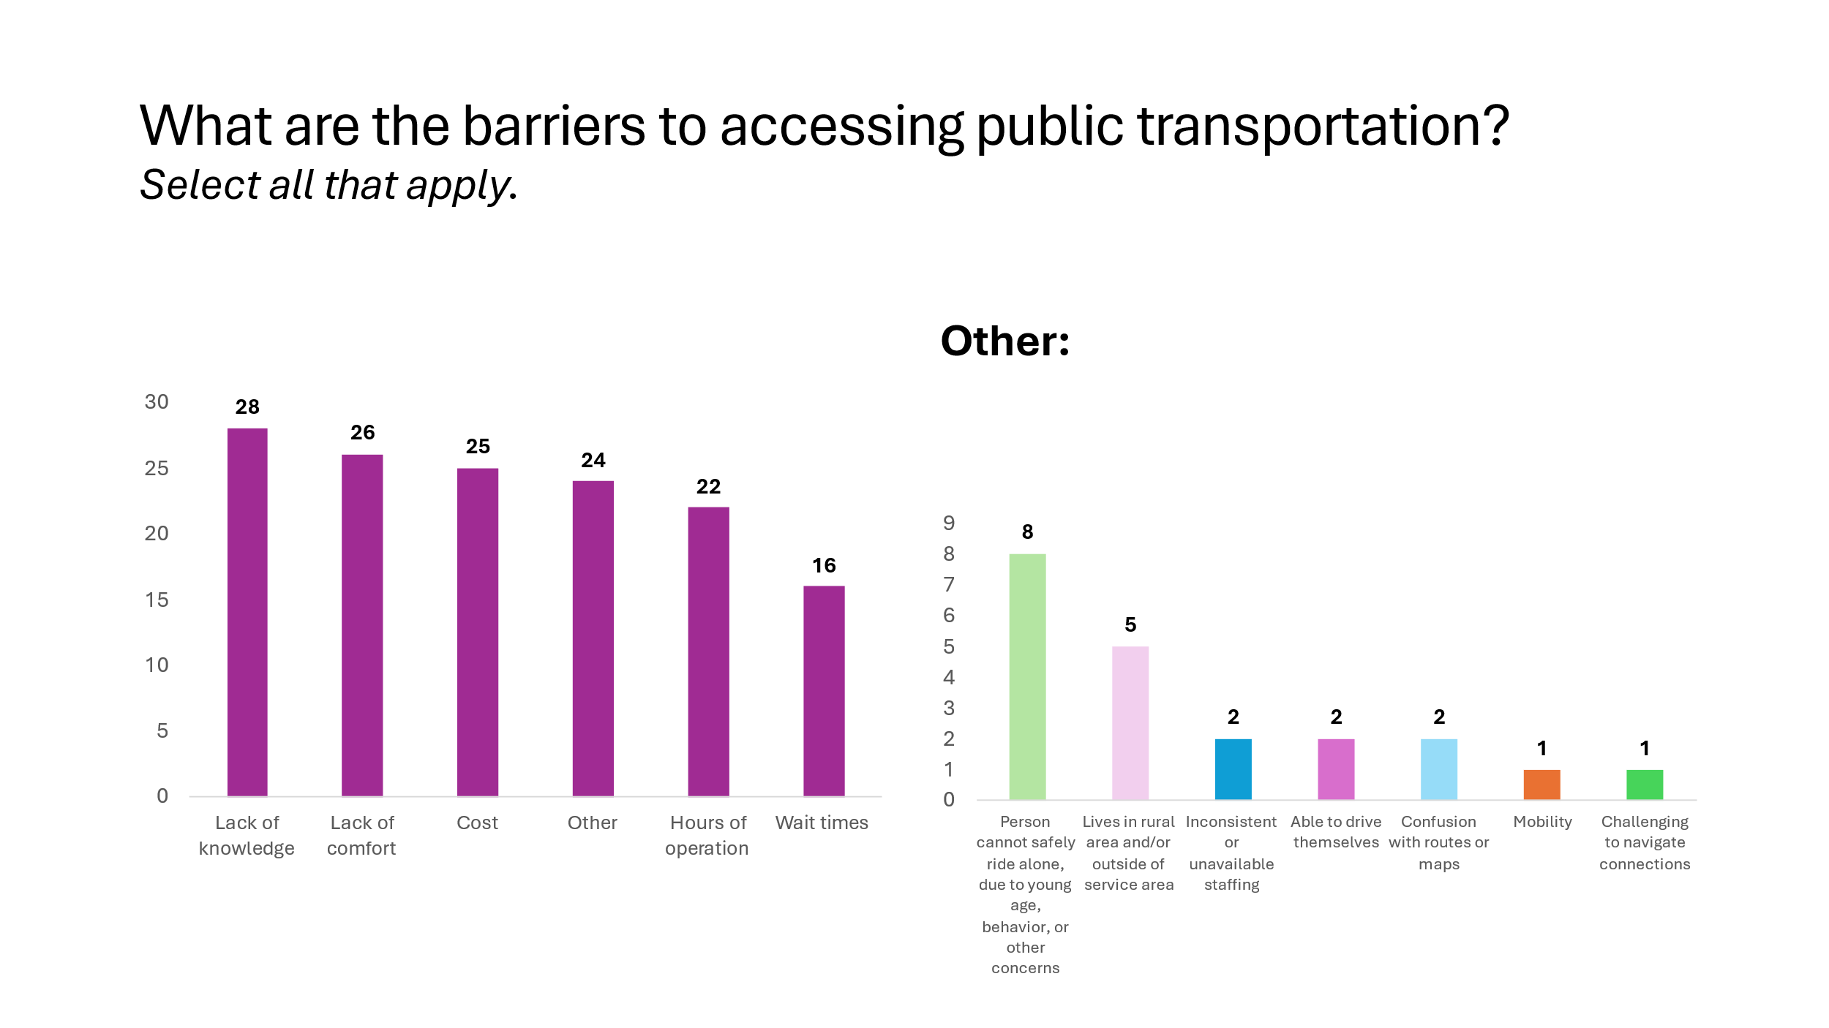
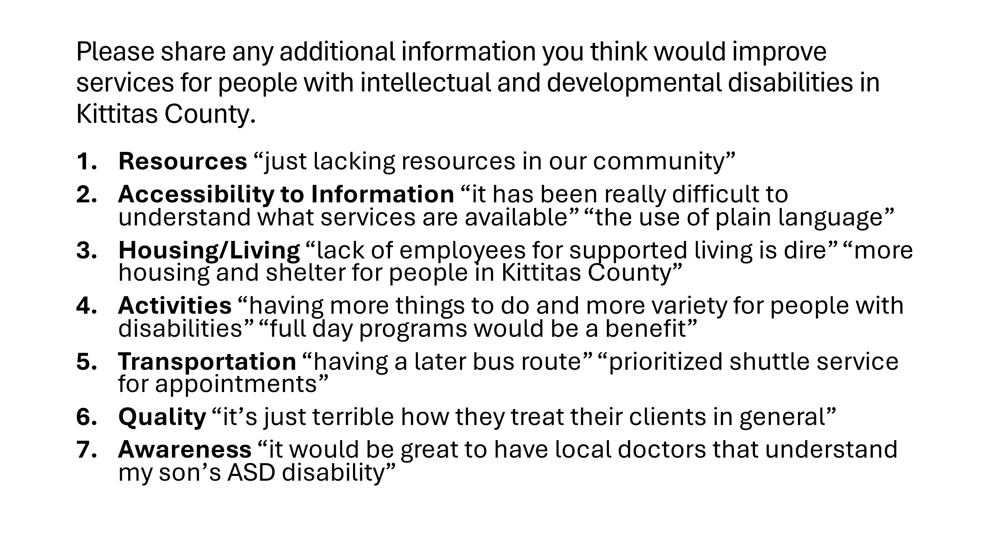

(Population of Cities, Towns, and Counties April 1, 2023)
(University of Wisconsin Population Health Institute 2023)
(University of Wisconsin Population Health Institute 2023)
(University of Wisconsin Population Health Institute 2023)
(U.S. Census Bureau 2020)
(Washington State Developmental Disabilities Administration 2023)
(U.S. Census Bureau 2020)
(Washington State Developmental Disabilities Administration 2023)
(American Community Survey 5 Year Estimates 2022)
(American Community Survey 5 Year Estimates 2022)
(Washington State Divsion of Vocational Rehabilitation 2022)
(Washington State Divsion of Vocational Rehabilitation 2022)
(Washington State Divsion of Vocational Rehabilitation 2022)
(American Community Survey 5 Year Estimates 2022)
(Washington State Divsion of Vocational Rehabilitation 2022)
(Washington State Divsion of Vocational Rehabilitation 2022)
(Washington State Office of Superintendent of Public Instruction 2024)
(Washington State Developmental Disabilities Administration 2023)
(Washington State Developmental Disabilities Administration 2023)
(Washington State Developmental Disabilities Administration 2023)
(Washington State Developmental Disabilities Administration 2023)

